ADW300-LoRaWAN Configuration Instructions
- V1.2
- 2025.08

Documentation version change log table
Version Number | Release Date | Change Summary | Notes
V1.0 | 2024-07 | Initial release
V1.1 | 2024-11-29 | Corrected the issue with the primary and secondary value address table; Corrected the issue with the decoder incorrectly recognizing CS byte. | Please note that some primary and secondary value addresses have been swapped.
V1.2 | 2025-0818 | Simplify the information, update the software configuration instructions, and update the decoder

catalogue
ADW300-LoRaWAN Configuration Instructions 1
1 Fast-Connect Settings Guide 3
2 Connect the meter 4
2.1 Connect the meter through RS485. 4
2.2 Communicate with meter using ADW300.exe . 4
3 Configure on the “LoRaWAN Parameter” page. 5
3.1 LoRaWAN info 5
3.1.1 DEVEUI 5
3.1.2 BAND 6
3.2 LoRaWAN Setting 7
3.2.1 APPEUI、APPKEY、Upload Interval 8
3.2.2 DataRate 8
3.3 Channel Setting 10
3.4 Packet Type 10
3.5 Updata Setting 11
3.5.1 Set the data to be uploaded 12
3.5.2 Num in Updata Setting 17
3.5.3 Need CS 18
3.5.4 Big endian 19
3.5.5 Updata in sec 20
4 Payload format. 21
4.1 Selectable Data Packet 21
4.1.1 Default field template 21
4.1.2 HEX format 21
4.1.3 Data list 22
4.1.4 Decoder for the initial template 25
4.2 Fixed Packet Of 2526 25
5 Complete address table 25
5.1 Secondary Data Part 1 26
5.2 Secondary Value Part 2 36
5.3 Primary Value (Real Value) Part 1 41
5.4 Primary Value (Real Value) Part 2 42

- Fast-Connect Settings Guide
Parameter | OTAA Default | Where to Change  ( Chapter)
Region | CN470, RU868, IN865, EU868, US915, AU915, KR920, AS923_1, AS923_2, AS923_3, AS923_4 | 3.1.2
DevEUI | Label on the front of the meter. | Not writable, but readable 3.1.1
Join EUI / AppEUI | 1122334455667788 | 3.2.1
AppKey (OTAA) | 11223344556677881122334455667788 | 3.2.1
NwkSKey / AppSKey (ABP) | - | -
Data Rate | DR4 (DR3 for US915) | 3.2.2
TX Power | 16 dBm | -
Channel Mask | 0-7 enabled | 3.3
Max Payload (bytes) | 220 bytes | 3.2.2
Data List | Default template | 4.1.3
LoRaWAN version (≥ 1.0.3) is supported.

The uploaded data has a default template, and the decoder :

- Connect the meter
  - Connect the meter through RS485.
Connect meter to a computer using an RS485 to USB converter.
The + sign on meter is connected to 21 port , and the – sign on meter is connected to 22 port.
For example:
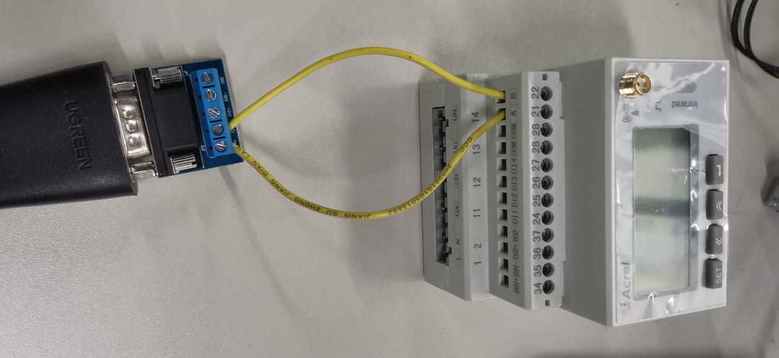
Then the meter should be powered through the power lines L (port 1) and N (port 2).

  - Communicate with meter using ADW300.exe .
ADW300 configuration software EN T version 1.1 and above are recommended
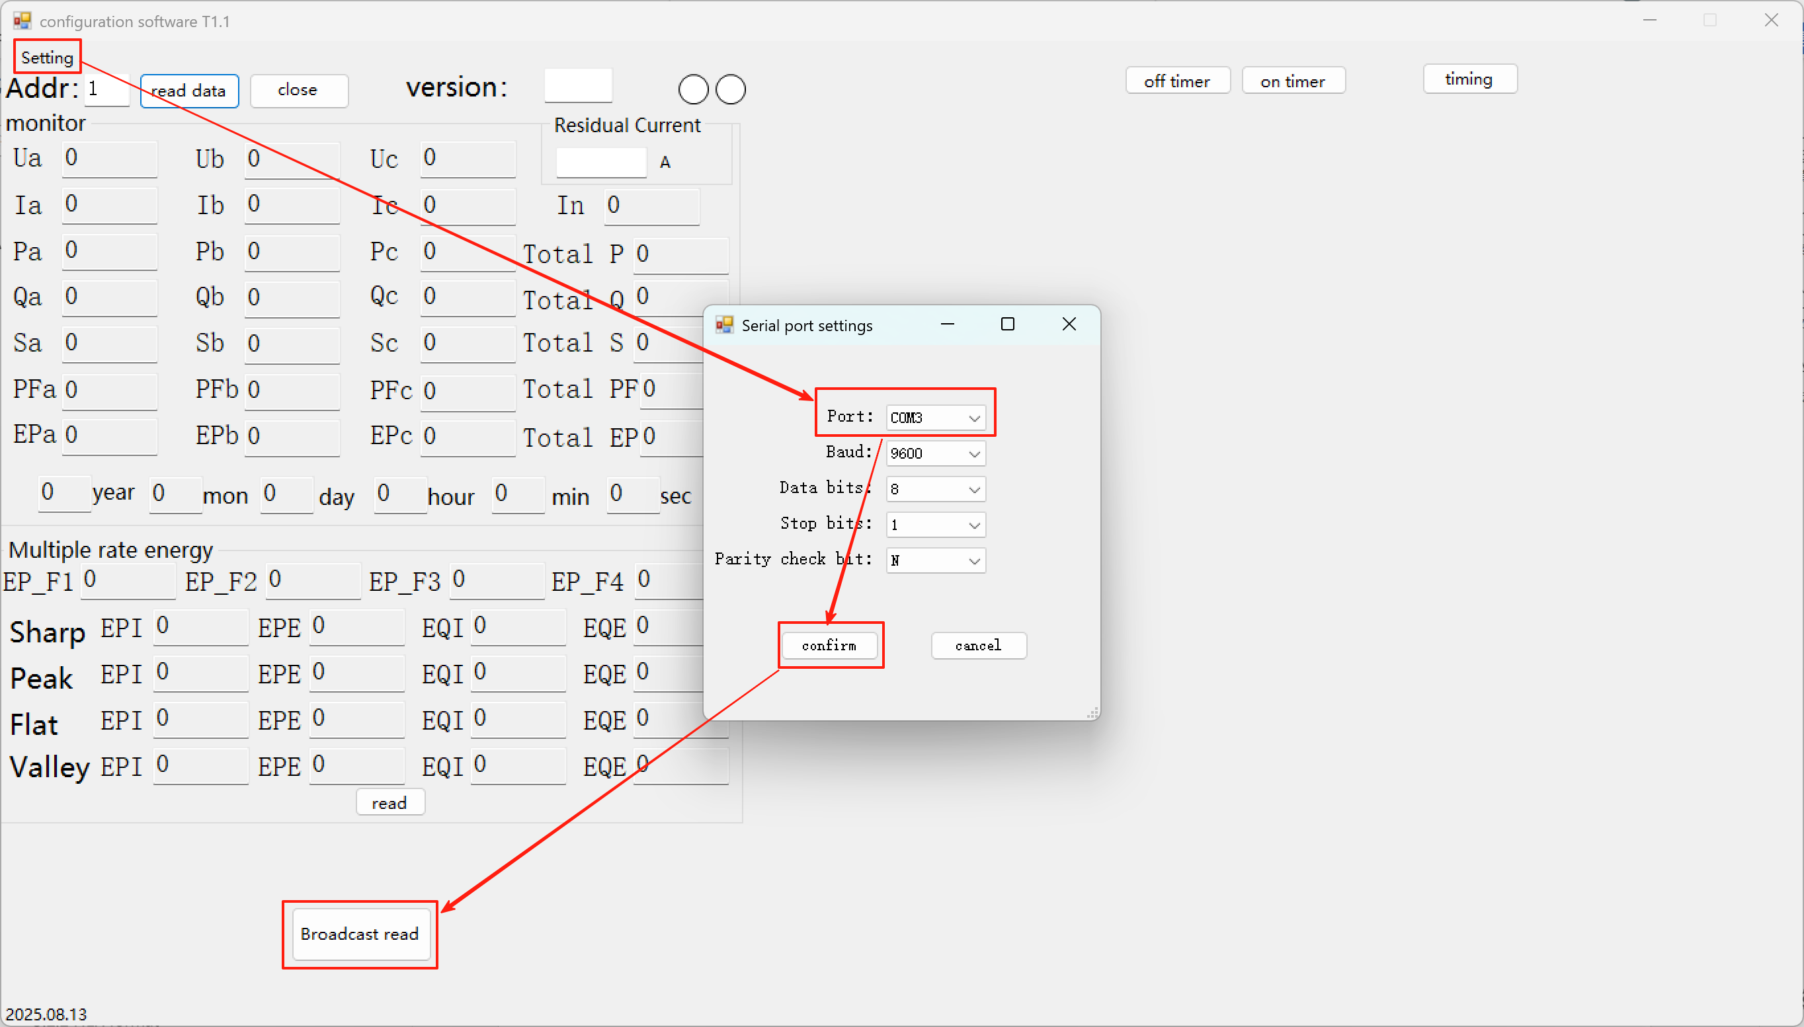

- Configure on the “LoRaWAN Parameter” page.
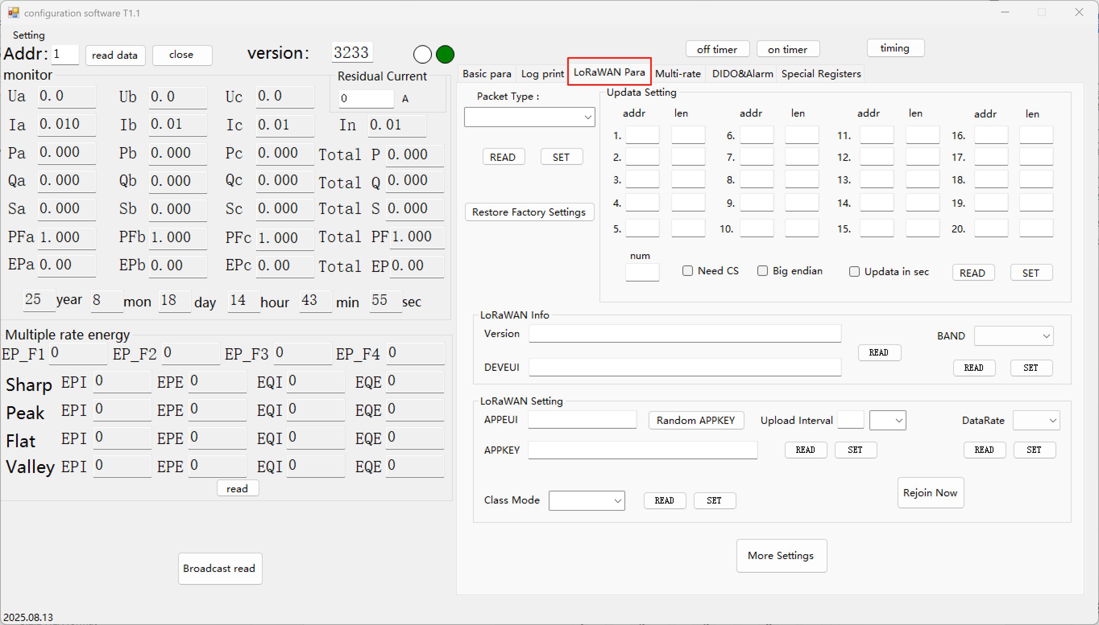
  - LoRaWAN info
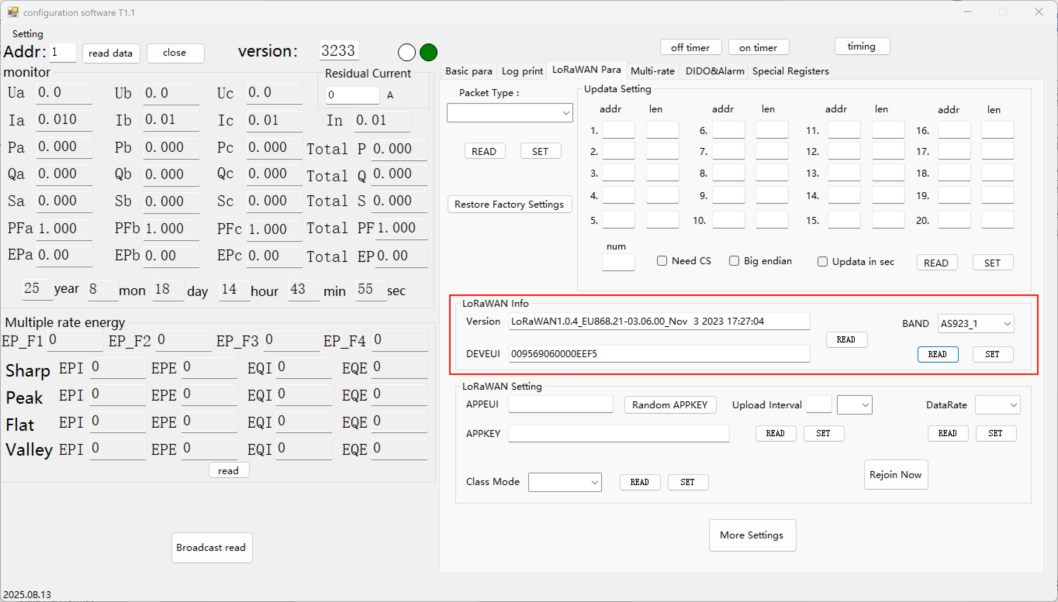

    - DEVEUI
Read the LoRaWAN Device EUI from the meter.
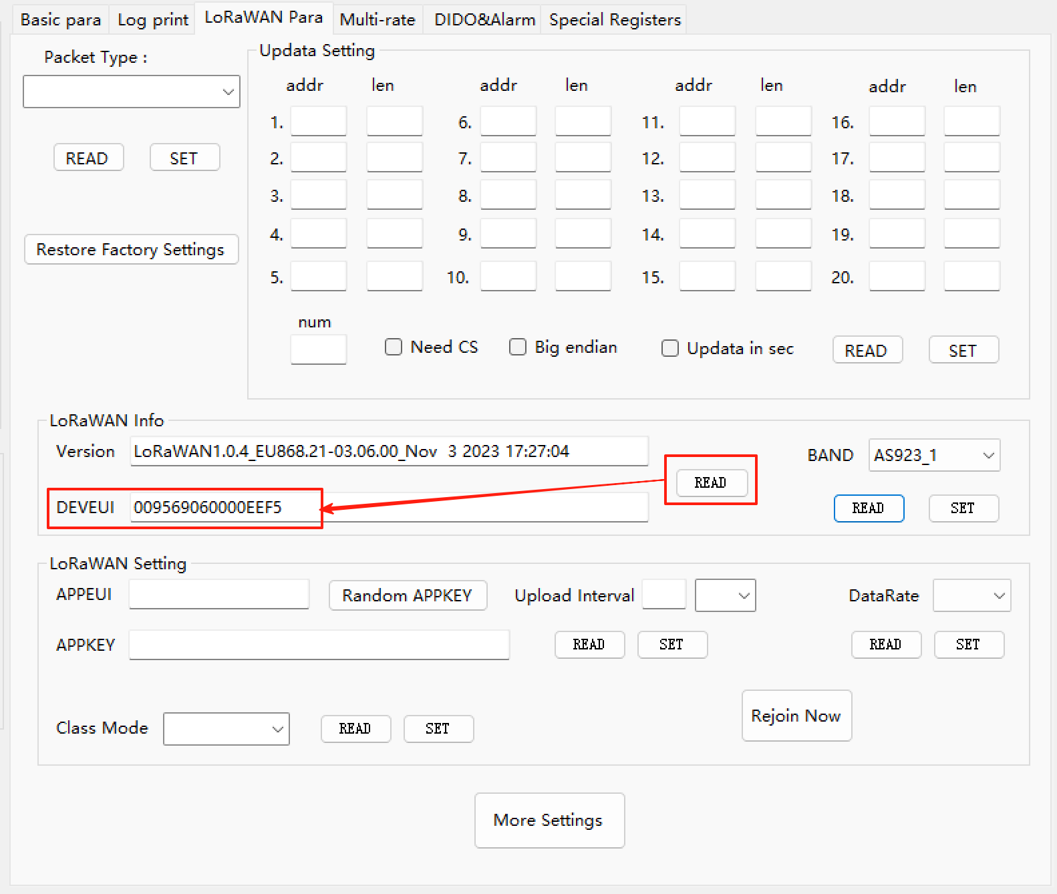

*At the same time, the firmware version number is read out for reference only when engineers debug, where the number has nothing to do with the actual operating frequency band of the module.

    - BAND
Region / Band Plan: RU868, IN865, EU868, US915, AU915, KR920, AS923_1, AS923_2, AS923_3, AS923_4.
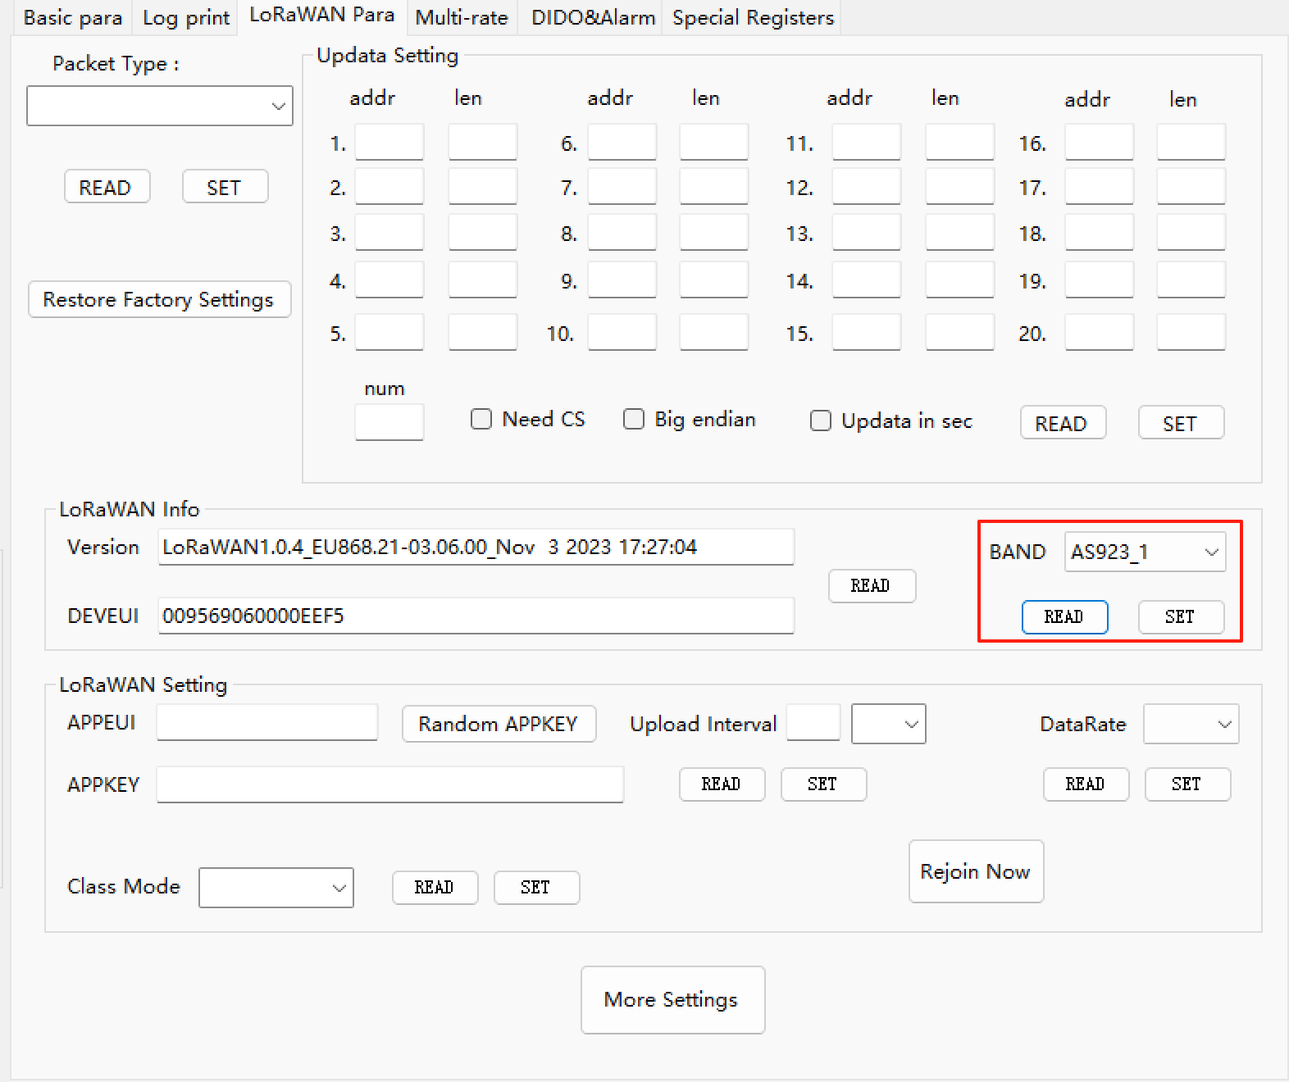

  - LoRaWAN Setting
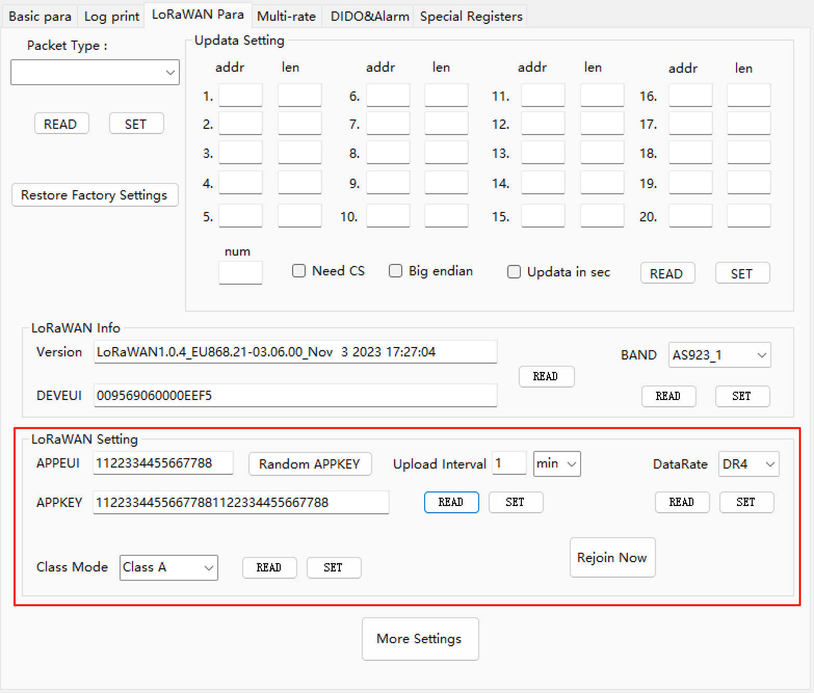

    - APPEUI、APPKEY、Upload Interval
They have an initial value at the factory, usually：
APPEUI：1122334455667788
APPKEY：11223344556677881122334455667788
Ramdom APPKEY : A random APPKEY value can be obtained.
Upload Interval (The time interval between data uploads)：1
Default unit : minute, can be change to second (at least 5 sec).
They can all be set to the desired number. Read the data before setting it.
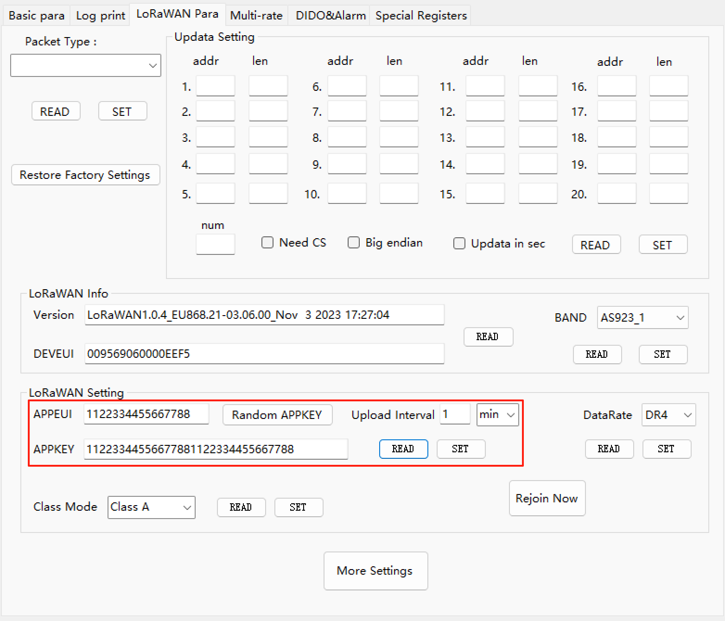

    - DataRate
The default DataRate is DR4. Due to the need to upload fixed length packets, ADR is disabled in the module, so we need to set a data transfer rate level that the module can recognize, which is DataRate. After setting, the corresponding spread spectrum factor is fixed, and the maximum length of data that can be sent per packet is fixed.
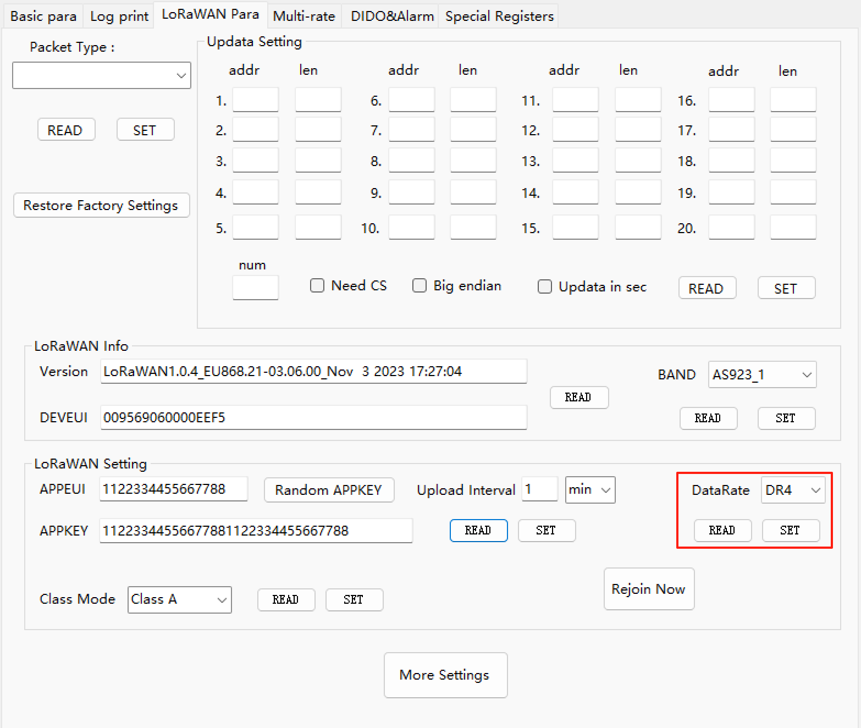
The maximum data load (unit: byte) of a single packet for each DataRate in each frequency band：
 | CN470 | EU868 | AU915 | US915 | AS923
DR0 | 50 | 50 | 50 | 10 | 50
DR1 | 50 | 50 | 50 | 50 | 50
DR2 | 50 | 50 | 50 | 110 | 50
DR3 | 110 | 110 | 110 | 220 | 110
DR4 | 220 | 220 | 220 | - | 220
DR5 | 220 | 220 | 220 | - | 220

The larger the DataRate Number, the smaller the spread factor and the shorter the transmission time, the more data information is transmitted per unit time, but the anti-interference ability is reduced, so the transmission distance is shortened.
On the contrary, you can improve the anti-interference of the transmission by setting a smaller DataRate, and extend the transmission distance, and he packet may be divided into more packets to be sent, depending on the corresponding single packet maximum load.

*The maximum DataRate Level corresponding to the US915 is DR3.

  - Channel Setting
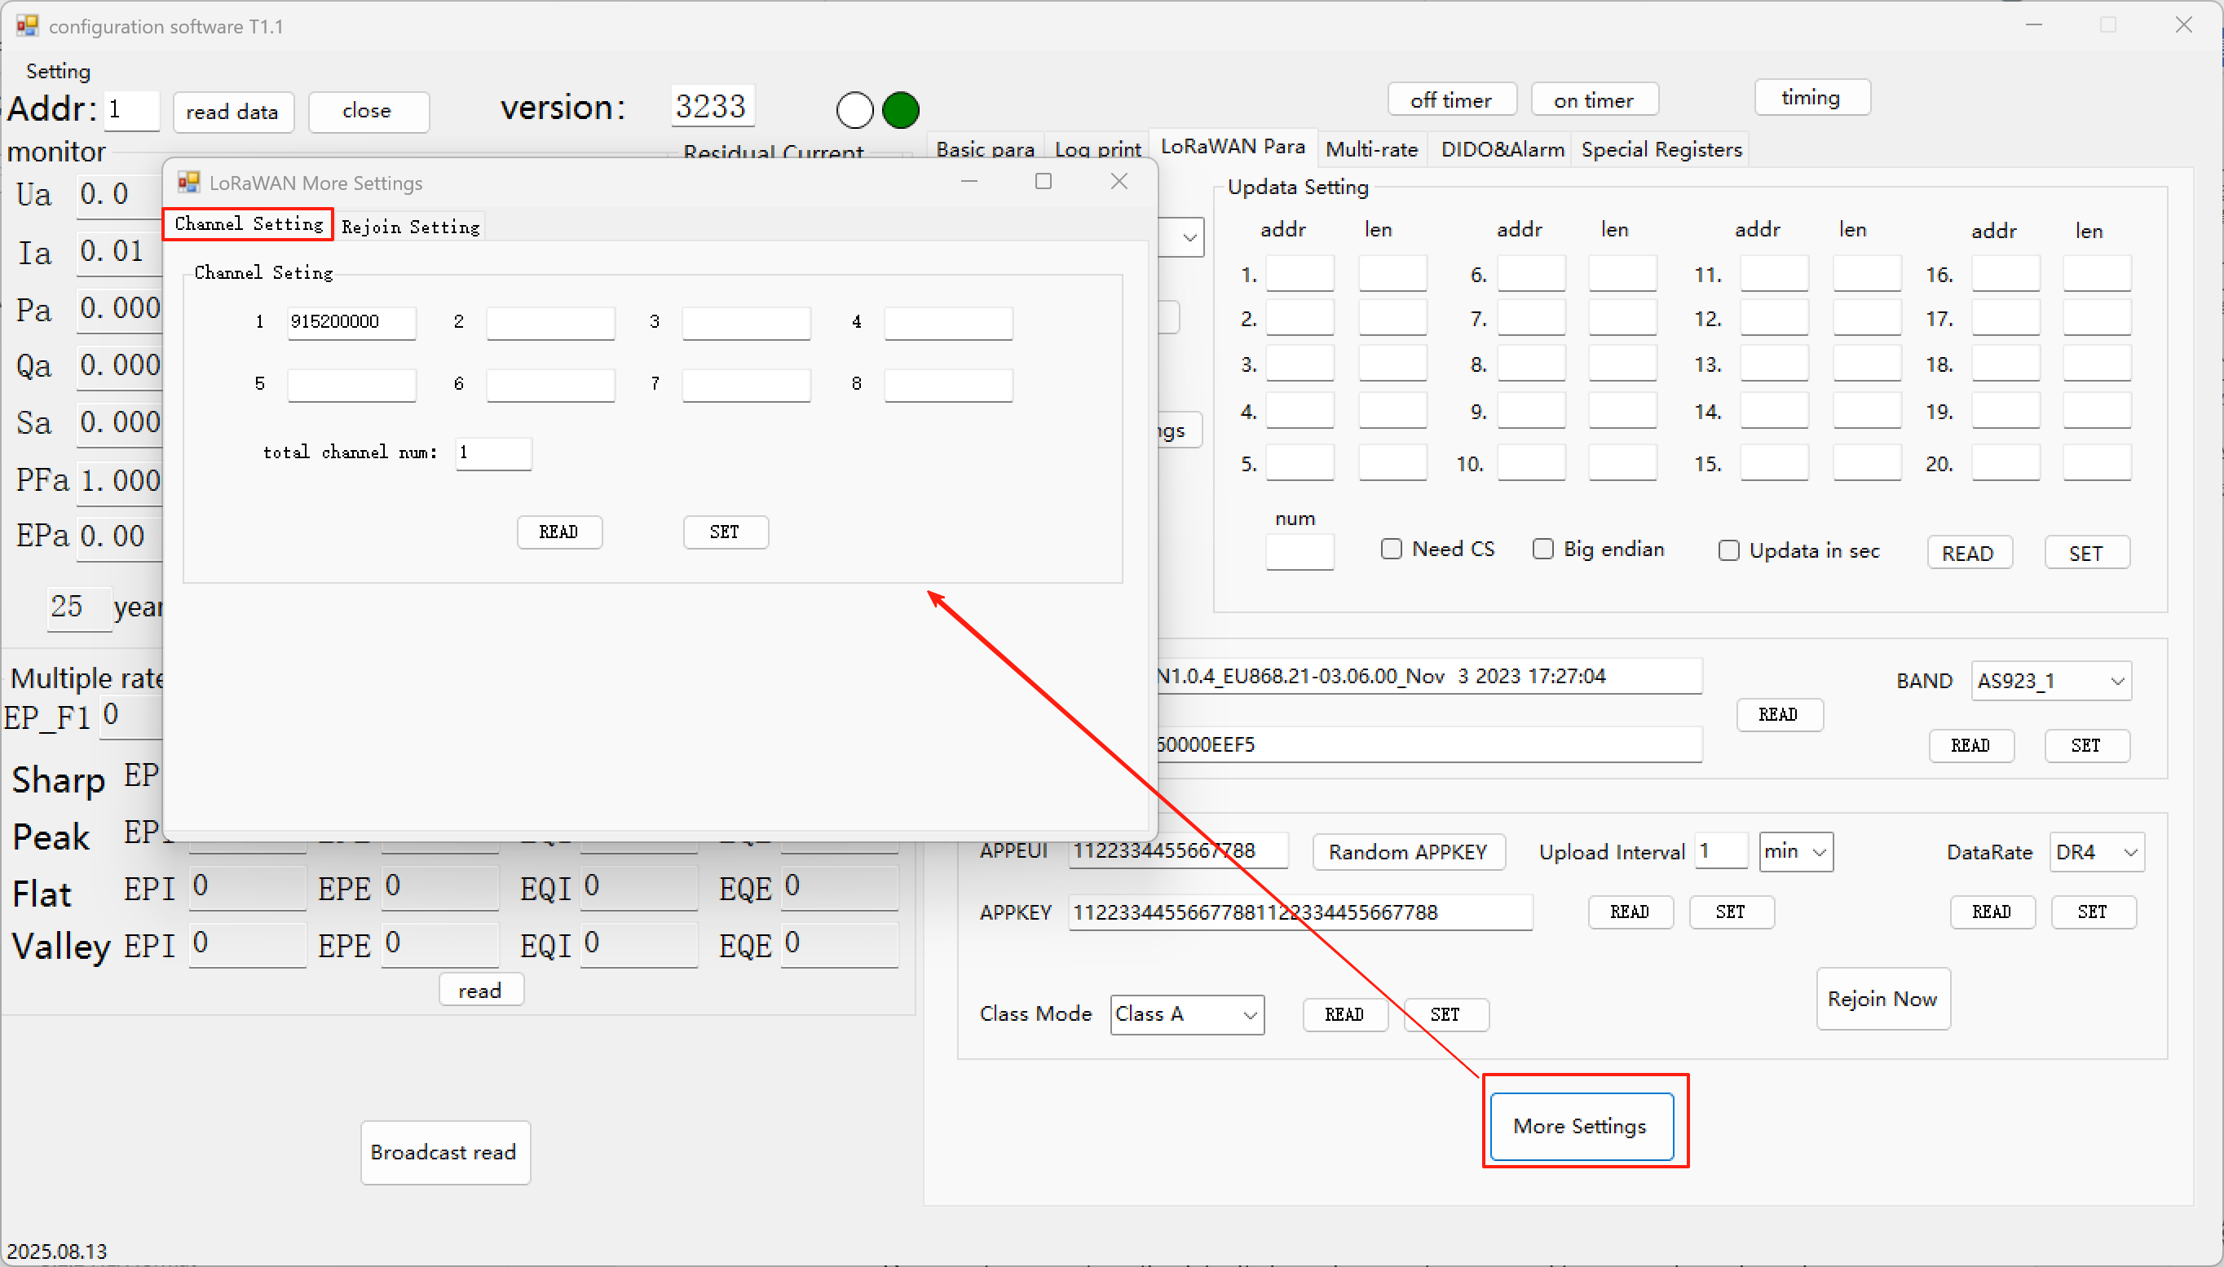
In general, the number of channels is set to 0, which means that the module will run on default channels within the Region / Band Plan.
Set the corresponding channel frequencies and the number of channels as needed. By default, for channels 0-7, the reading will not display the default values

A maximum of 8 channels can be configured. Start channel 922.2MHz, which can be set to 922200000. Enable 8 channels starting from 922200000.
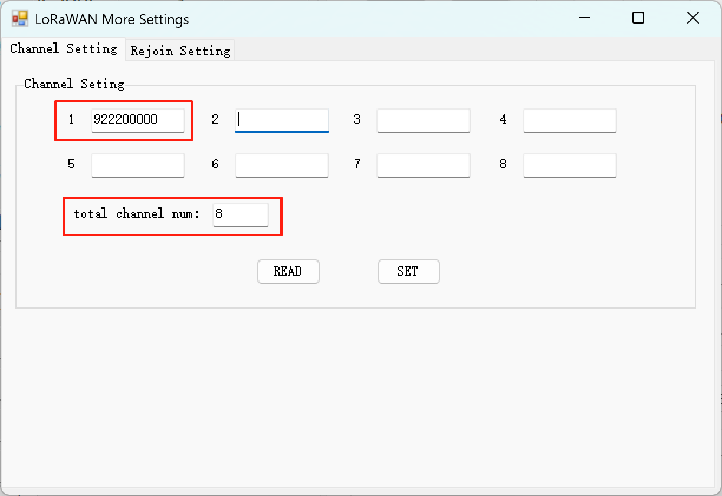

  - Packet Type
Click Read to view the data packet mode currently in use.
Selectable Data Packet：Default mode. In this mode, there is a default data template available for upload. It can also be customized. The information in "Updata Setting" is the data template.
Fixed Packet of 2526：Special template, upload data is fixed. In this mode, updata settings cannot be modified.
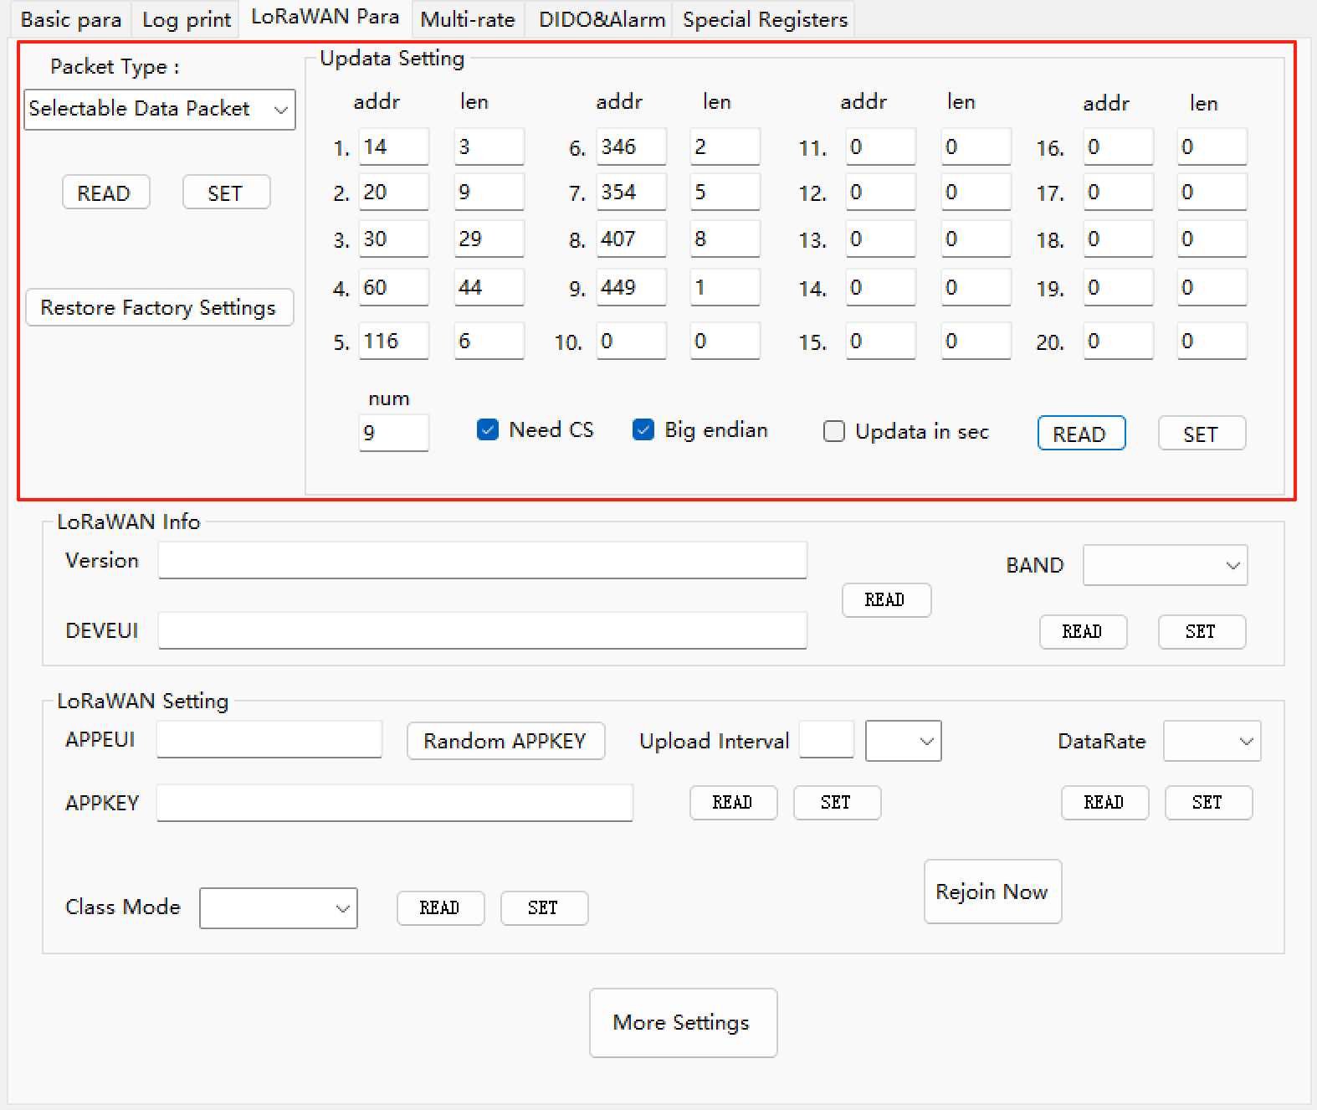

  - Updata Setting
This is the setting of what data the meter uploads. You can select the required data fields according to the complete address table, all the start address and register length can be found in the complete address table. We can choose to upload the secondary value or the primary value(real value). Or use the default field template. The following is a description of the Updata Settings.
    - Set the data to be uploaded
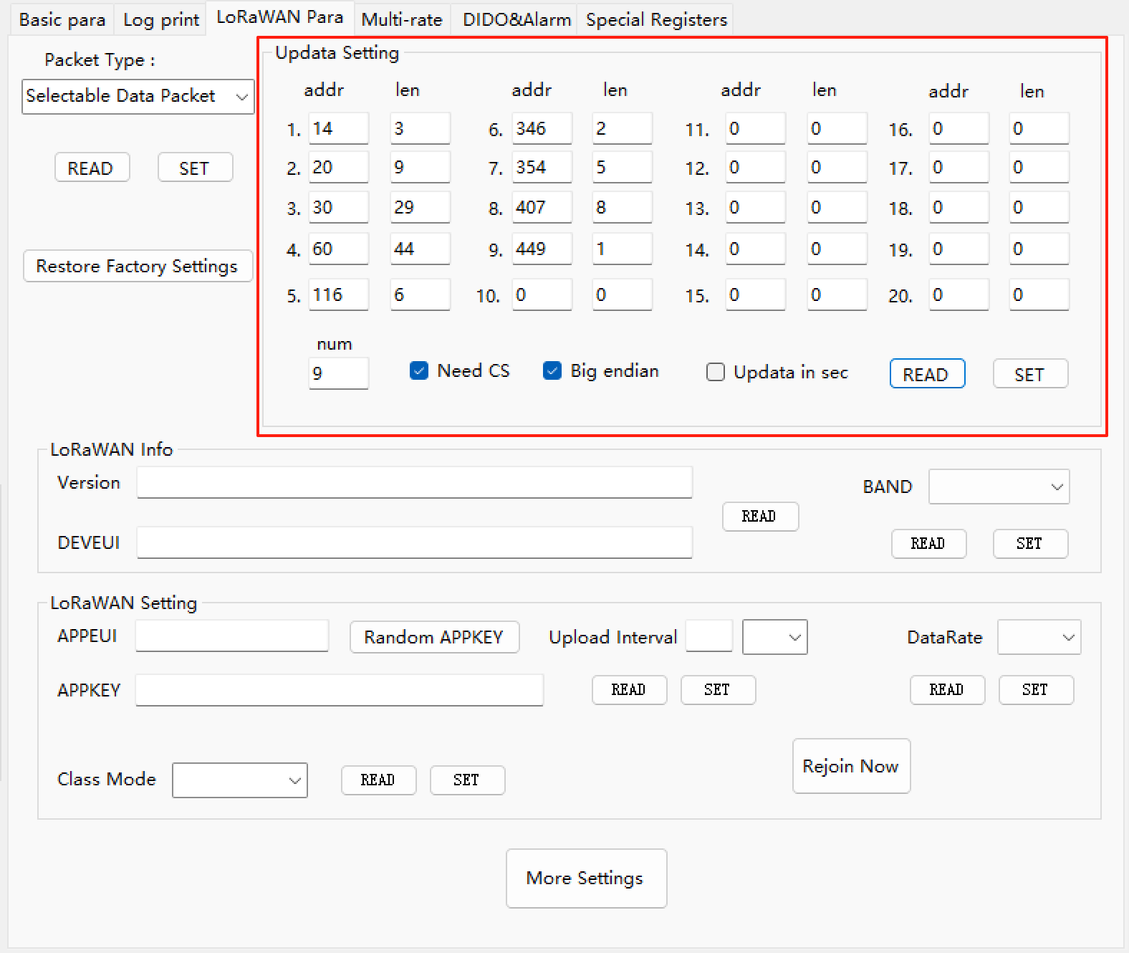

      - Select adjacent parameters
When we want to upload the data include PT、CT、Temperature of N phase. We first find the position of the parameter in the data table, like this PT, whose start address is 14. The next one is CT, start address is 15. And then Temperature of N phase, start address is 16.
You can see that after the name of the parameter in the table is the number of bytes, this value divided by 2 is the size of the register occupied by the parameter.
2 (bytes) / 2 = 1 (register),
4 (bytes) / 2 = 2 (register).
From 14 to 16, there are 3 registers.
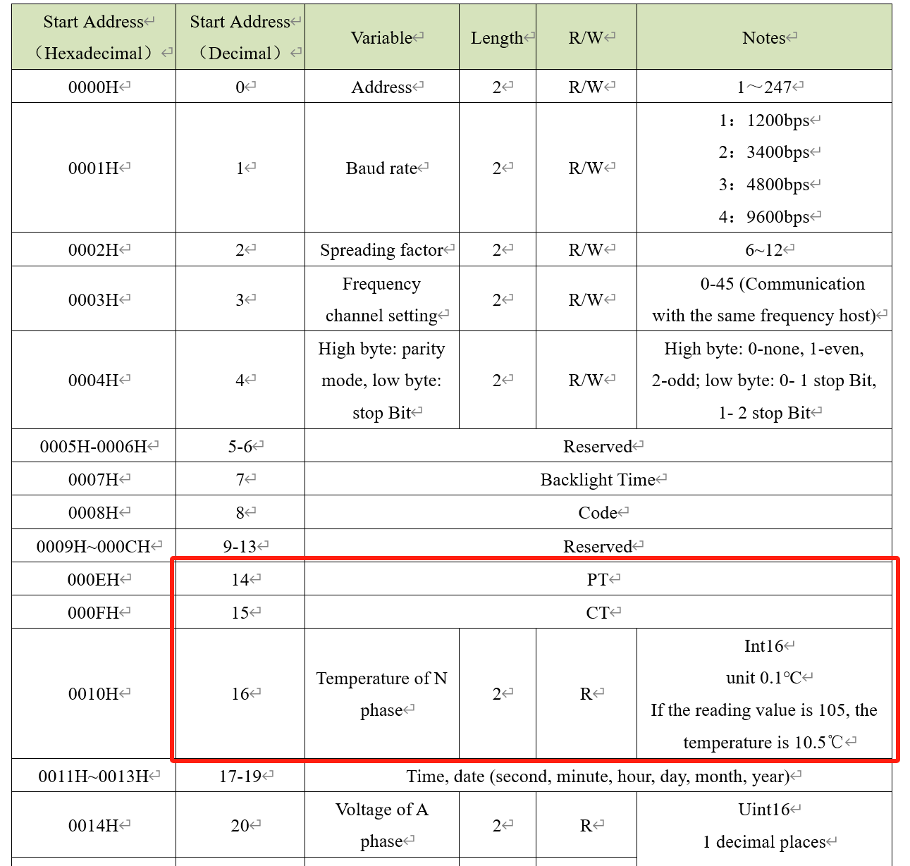

So when we set a group of the data, we fill in the start address first, the address is 14. And then the register length, which is 3. So that the three parameters selected will be added to the package in order.
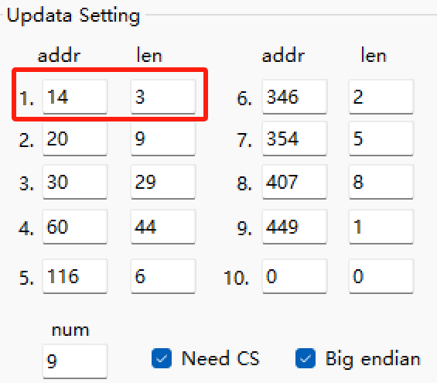

      - Select parameters that are not adjacent
A group of data must be in adjacent states. When you need non-adjacent data, you can set it in different groups.
When we want the data include UA、UB、UC、UAB、UBC、UCA、IA、IB、IC. But they are not adjacent to the n-phase temperature parameter, so we need to set it to the new group.
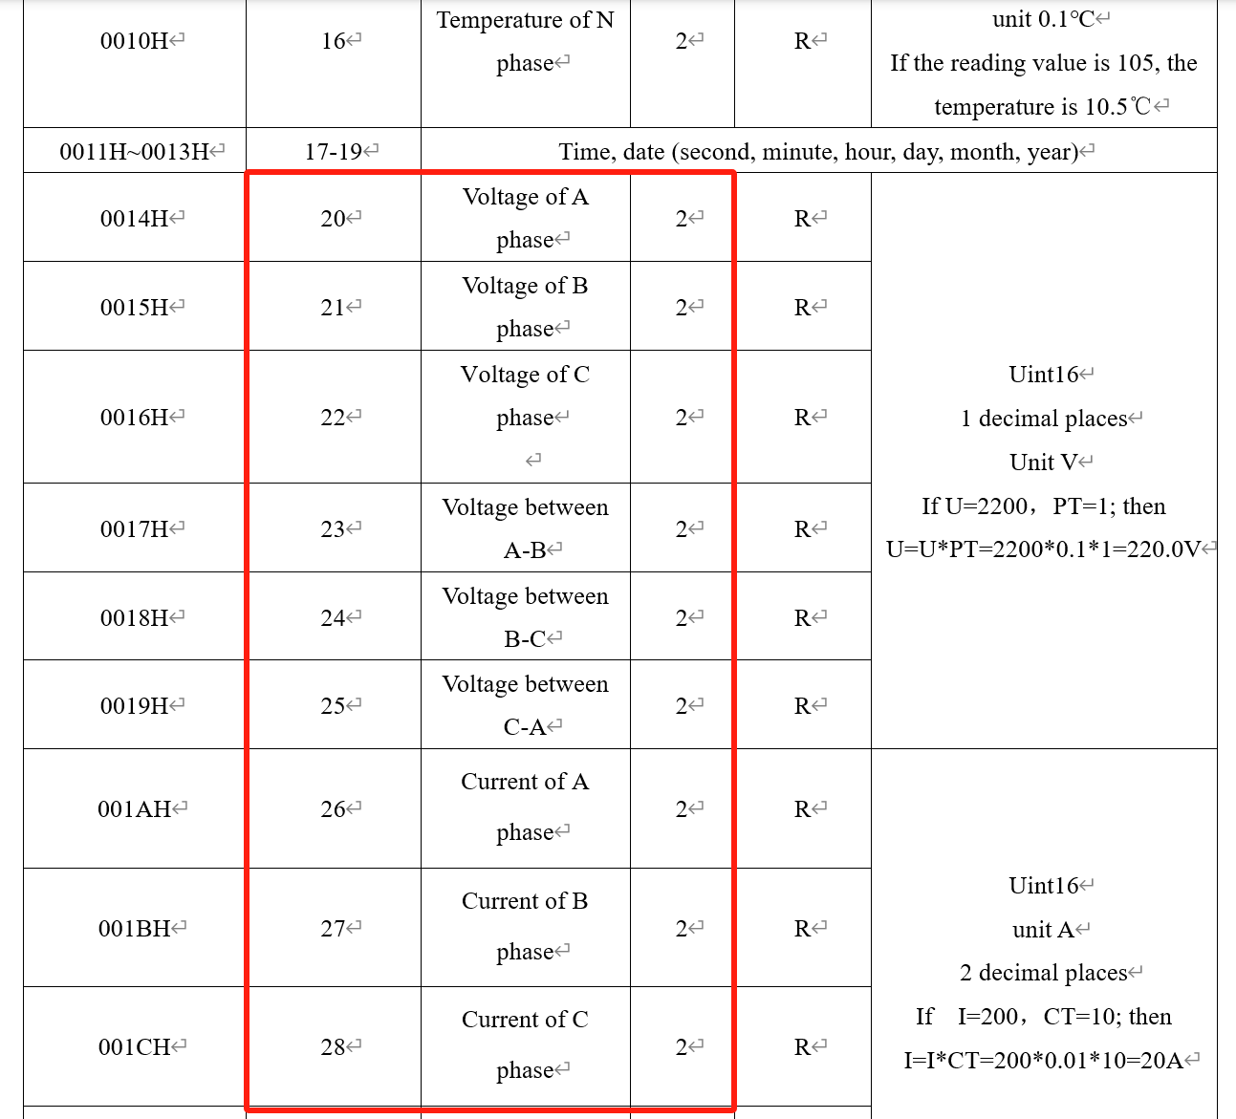

So we find the start address is 20, Each data account for 1 register, so there are 9 registers in total. Then we set like :
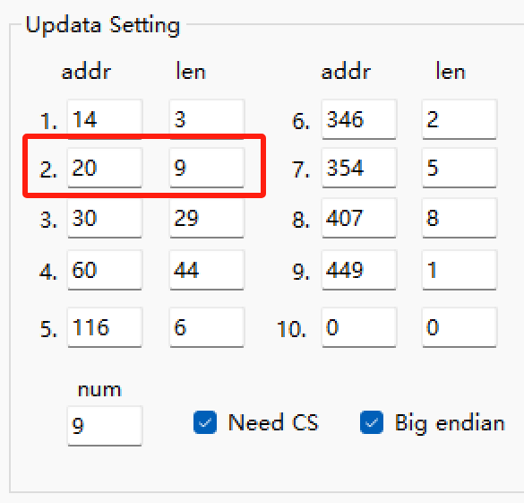

      - Selects data that occupies two registers
When we need more parameters such as Active power of A phase, it may be involved that some data is 4 bytes in the address table, that is, 2 registers, which is twice the size of the normal data. We just need to calculate the total number of registers that this set of data actually occupies.
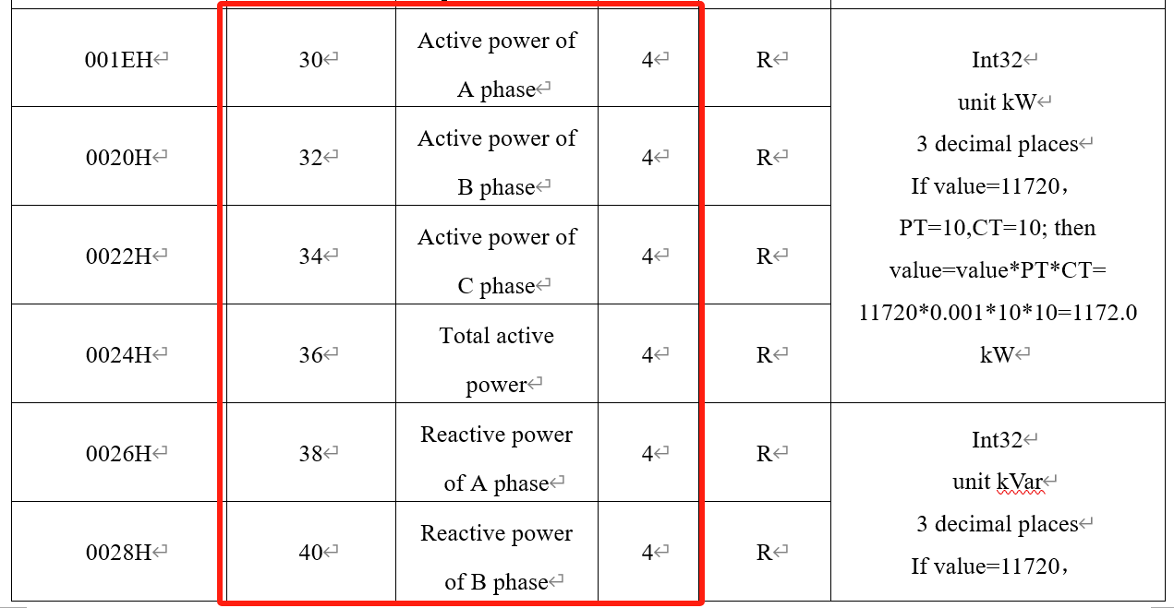
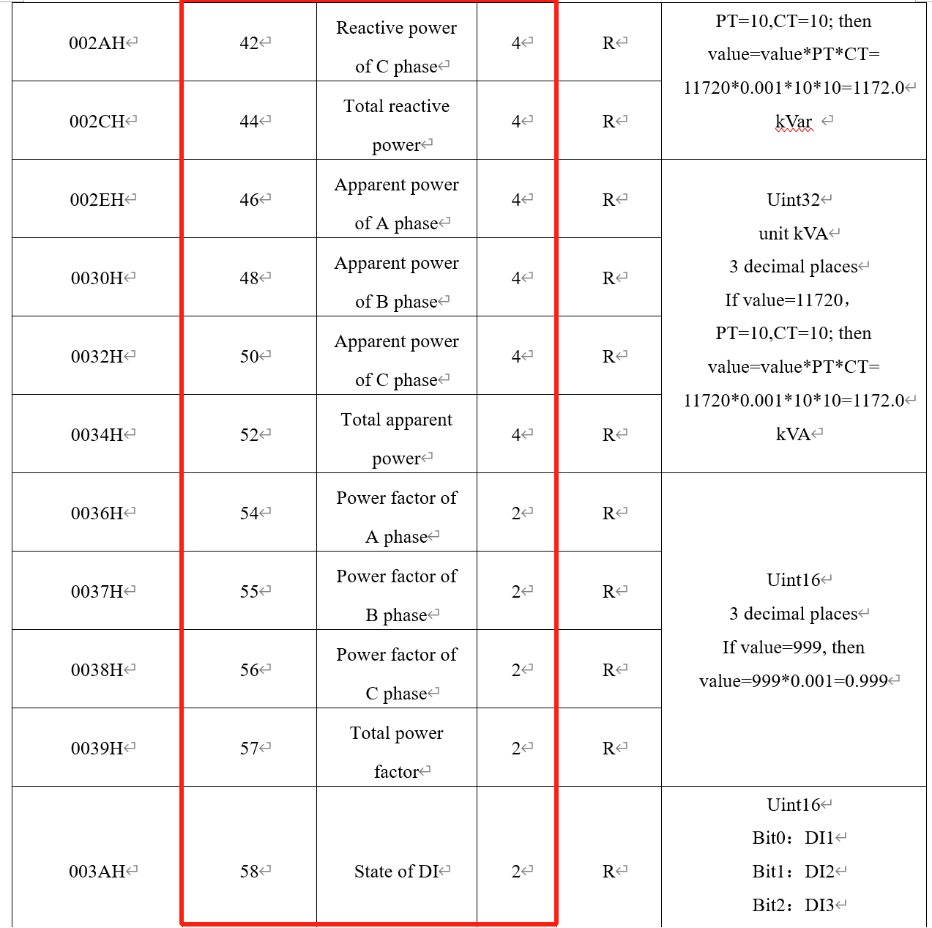

As shown in the table, we need these data, some data account for 4 bytes, and some data account for 2 bytes, converted to the number of registers, the sum can be 29 registers. So we fill in the start address and the number of registers as follows:
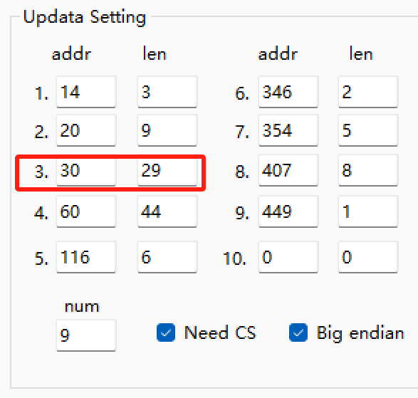
    - Num in Updata Setting
Num is the number of valid data groups. There are a total of 20 groups that can be filled in, and after filling in the required data group, fill in the rest of the 0.
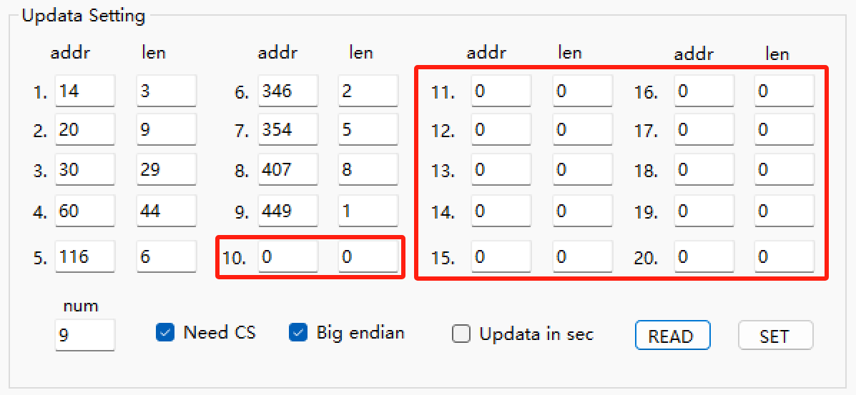

Finally set the total number of groups. Like the picture, there are 9 groups of data, so set num 9.
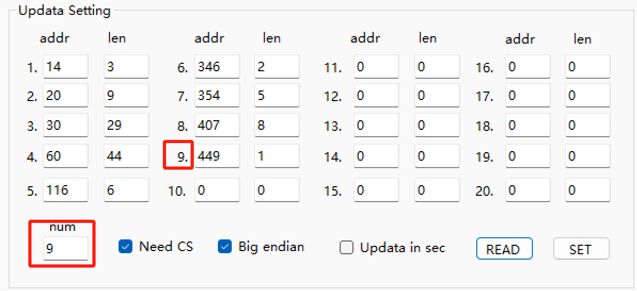

If the num value is less than the total number of data groups you entered, for example, we entered 9 groups here, but if num only enter 1, only the first set of data will be uploaded in the data packet. The packet only includes PT、CT、Temperature of N phase. No other data will be uploaded.
* The byte size or number of registers that data represents in the data address table does not represent the byte length that data will occupy when it is finally uploaded. Whether the selected data is originally 2 bytes or 4 bytes, it is unified to 5 bytes per parameter (1 sequence number +4 bytes of data) when uploaded.

    - Need CS
Enable to add a CS checksum byte to the end of the uploaded data packet.
This option is selected by default for the initial template
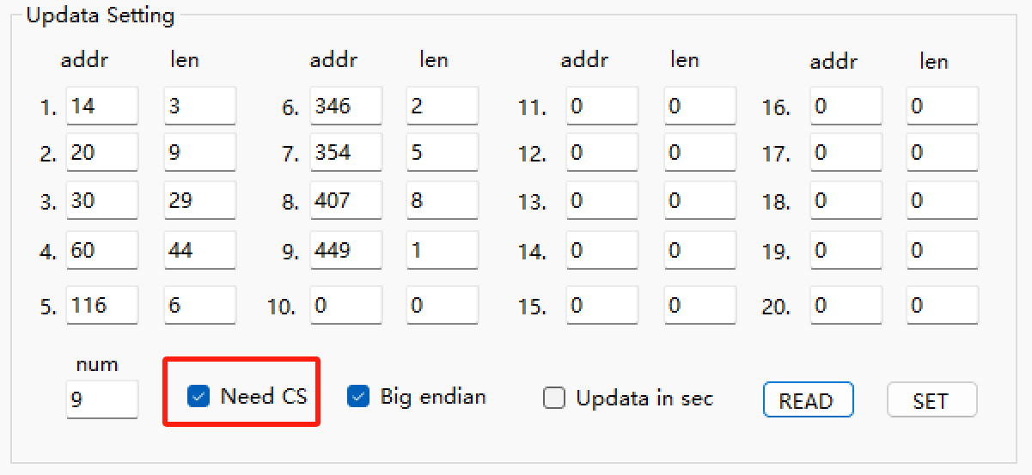

Checksum: All the data in the uploaded packet is added to obtain a value, and then the value is divided by 256 to obtain a remainder, which is the CS checksum.
For example, a packet contains this data:
01 00 00 00 01 02 00 00 00 01
If we need CS, then the CS checksum is added to the end:
01 00 00 00 01 02 00 00 00 01 05
So in the absence of CS, the packet size is a multiple of 5. If we add CS it's a multiple of 5, plus 1 byte.

The function of CS checksum calculation is constructed by C language:
//pBus[] is the data buffer.
// start is the location of the first data.
// n is the number of bytes computed.
uint8_t CS16(uint8_t* pBus, uint16_t start, uint16_t n)
{
Uint16_t i;
uint8_t sum = 0;
for (i = start ; i < n+start ; i++)
{
sum = ( sum + pBus[i] ) % 256;
}
return sum;
}
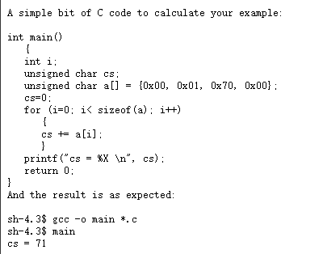

    - Big endian
Select whether we want big endian.
This option is selected by default for the initial template.
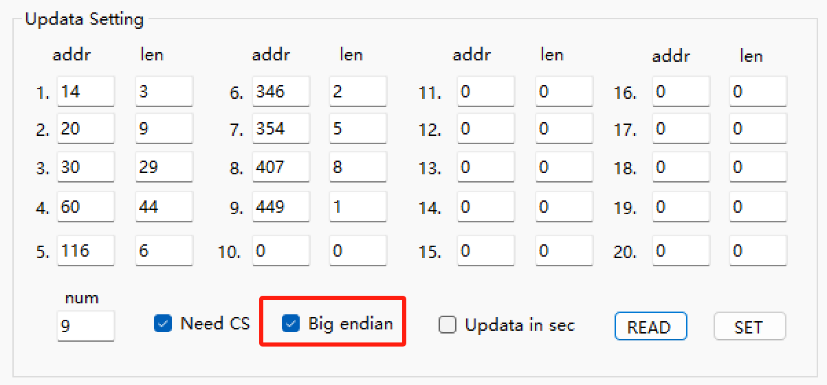

If we upload a parameter with a value of 0x12345678, then in the big endian condition it looks like this:
num value
01 12 34 56 78
In the small endian condition it looks like this:
num value
01 78 56 34 12
    - Updata in sec
After this function is enabled, the data upload frequency changes from minute to second. For example, the original data frequency was 5, and the data was uploaded every 5 minutes. After the second level upload was enabled, the data was uploaded every 5 seconds.
It is not selected by default. If you need to use it, consult engineers first.
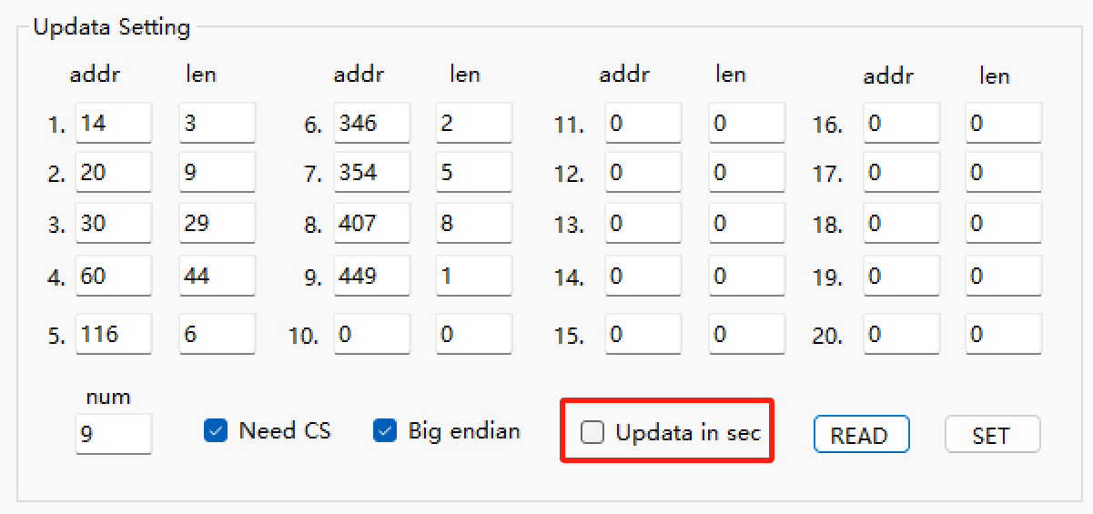

- Payload format.
  - Selectable Data Packet
By default, or by selection, the packet type is Selectable Data Packet. In this mode, there is an initial template, and we can also customize it.
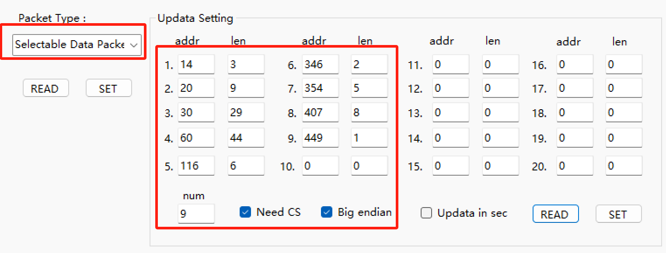

    - Default field template
The initial template contains a total of 9 data groups, including 68 parameters and 1 CS checksum. The data is in big endian.
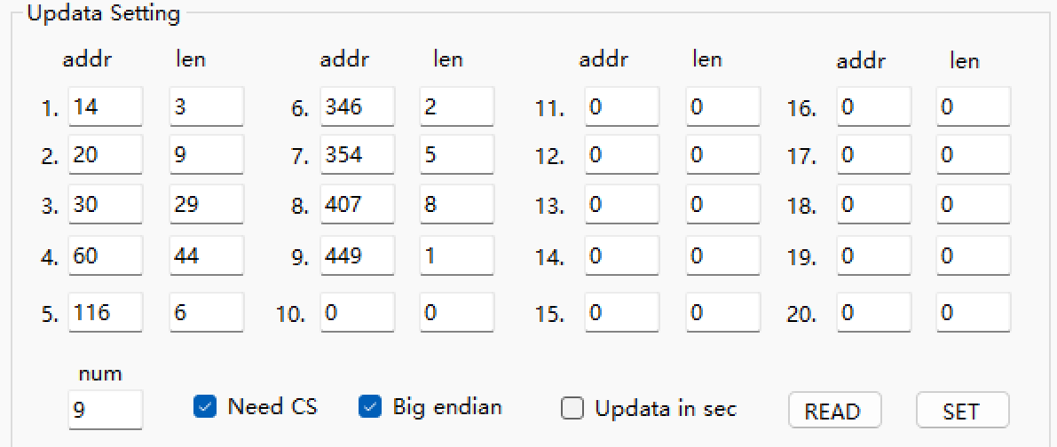

    - HEX format
04 00 00 08 98 (=2200)
Number (1 byte) + Data Value (4 bytes)
All parameters have 4 bytes of space in the packet, but the data type may be int16, uint16, int32, uint32, float. What is the specific type of the value of each parameter according to the data list or address table.

There is a checksum at the last of all data.

Uploaded data:

01 00 00 00 01 02 00 00 00 01 03 00 00 00 00 04 00 00 00 00 05 00 00 00 00 06 00 00 00 00 07 00 00 00 00 08 00 00 00 00 09 00 00 00 00 0A 00 00 00 01 0B 00 00 00 01 0C 00 00 00 01 0D 00 00 00 00 0E 00 00 00 00 0F 00 00 00 00 10 00 00 00 00 11 00 00 00 00 12 00 00 00 00 13 00 00 00 00 14 00 00 00 00 15 00 00 00 00 16 00 00 00 00 17 00 00 00 00 18 00 00 00 00 19 00 00 03 E8 1A 00 00 03 E8 1B 00 00 03 E8 1C 00 00 03 E8 1D 00 00 00 00 1E 00 00 00 00 1F 00 00 00 00 20 00 00 00 00 21 00 00 00 00 22 00 00 00 00 23 00 00 00 00 24 00 00 00 00 25 00 00 00 00 26 00 00 00 00 27 00 00 00 00 28 00 00 00 00 29 00 00 00 00 2A 00 00 00 00 2B 00 00 00 00 2C 00 00 00 00 2D 00 00 00 00 2E 00 00 00 00 2F 00 00 00 00 30 00 00 00 00 31 00 00 00 00 32 00 00 00 00 33 00 00 00 00 34 00 00 00 00 35 00 00 00 00 36 00 00 00 00 37 00 00 00 00 38 00 00 00 00 39 00 00 00 00 3A 00 00 00 00 3B 00 00 00 00 3C 00 00 00 00 3D 00 00 00 00 3E 00 00 00 00 3F 00 00 00 00 40 00 00 00 00 41 00 00 00 00 42 00 00 00 00 43 00 00 00 00 44 00 00 00 00 9E
Notice : Mostly data are secondary side values from the meter. Need to deal data for getting real value.

    - Data list
The following table lists the data for the initial template. And the table explains how to process the secondary value data to obtain the primary value(real value) data:
Num in packet  (Hex) | Variable | Data type | Unit | Notes
01 | PT | Uint16 | 1
02 | CT | Uint16 | 1
03 | Temperature of N phase | Int16 | 0.1℃ | If the reading value is 105, the temperature is 10.5℃
04 | Voltage of A phase | Uint16 | 0.1V | If U=2200，PT=1; then U=U*PT=2200*0.1*1=220.0V
05 | Voltage of B phase | Uint16 | 0.1V
06 | Voltage of C phase | Uint16 | 0.1V
07 | Voltage between A-B | Uint16 | 0.1V
08 | Voltage between B-C | Uint16 | 0.1V
09 | Voltage between C-A | Uint16 | 0.1V
0A | Current of A phase | Uint16 | 0.01A | If I=200，CT=10; then I=I*CT  =200*0.01*10=20A
0B | Current of B phase | Uint16 | 0.01A
0C | Current of C phase | Uint16 | 0.01A
0D | Active power of A phase | int32 | 0.001kW | If value=11720， PT=10,CT=10; then value=value*PT*CT= 11720*0.001*10*10=1172.0 kW
0E | Active power of B phase | Int32 | 0.001kW
0F | Active power of C phase | Int32 | 0.001kW
10 | Total active power | Int32 | 0.001kW
11 | Reactive power of A phase | Int32 | 0.001kVar | If value=11720， PT=10,CT=10; then value=value*PT*CT= 11720*0.001*10*10=1172.0 kVar
12 | Reactive power of B phase | Int32 | 0.001kVar
13 | Reactive power of C phase | Int32 | 0.001kVar
14 | Total reactive power | Int32 | 0.001kVar
15 | Apparent power of A phase | Uint32 | 0.001kVA | If value=11720， PT=10,CT=10; then value=value*PT*CT= 11720*0.001*10*10=1172.0 kVA
16 | Apparent power of B phase | Uint32 | 0.001kVA
17 | Apparent power of C phase | Uint32 | 0.001kVA
18 | Total apparent power | Uint32 | 0.001kVA
19 | Power factor of A phase | Uint16 | 0.001 | If value=999, then value=999*0.001=0.999
1A | Power factor of B phase | Uint16 | 0.001
1B | Power factor of C phase | Uint16 | 0.001
1C | Total power factor | Uint16 | 0.001
1D | State of DI | Uint16 | 0 or 1 | Bit0：DI1  Bit1：DI2  Bit2：DI3  Bit3：DI4
1E | Total energy consumption | Uint32 | 0.01 kWh | If value=120201， PT=10,CT=10;then value=value*PT*CT= 120201*0.01*10*10=120201 kWh
1F | Forward active energy consumption | Uint32 | 0.01 kWh
20 | Reversing active energy consumption | Uint32 | 0.01 kWh
21 | Forward reactive energy consumption | Uint32 | 0.01 kVarh | If value=120201， PT=10,CT=10;then value=value*PT*CT= 120201*0.01*10*10=120201 kVarh
22 | Reversing reactive energy consumption | Uint32 | 0.01 kVarh
23 | Total energy consumption on A phase | Uint32 | 0.01 kWh | If value=120201， PT=10,CT=10;then value=value*PT*CT= 120201*0.01*10*10=120201 kWh
24 | Forward active energy consumption on A phase | Uint32 | 0.01 kWh
25 | Reversing active energy consumption on A phase | Uint32 | 0.01 kWh
26 | Forward reactive energy consumption on A phase | Uint32 | 0.01 kVarh | If value=120201， PT=10,CT=10;then value=value*PT*CT= 120201*0.01*10*10=120201 kVarh
27 | Reversing reactive energy consumption on A phase | Uint32 | 0.01 kVarh
28 | Total energy consumption on B phase | Uint32 | 0.01 kWh | If value=120201， PT=10,CT=10;then value=value*PT*CT= 120201*0.01*10*10=120201 kWh
29 | Forward active energy consumption on B phase | Uint32 | 0.01 kWh
2A | Reversing active energy consumption on B phase | Uint32 | 0.01 kWh
2B | Forward reactive energy consumption on B phase | Uint32 | 0.01 kVarh | If value=120201， PT=10,CT=10;then value=value*PT*CT= 120201*0.01*10*10=120201 kVarh
2C | Reversing reactive energy consumption on B phase | Uint32 | 0.01 kVarh
2D | Total energy consumption on C phase | Uint32 | 0.01 kWh | If value=120201， PT=10,CT=10;then value=value*PT*CT= 120201*0.01*10*10=120201 kWh
2E | Forward active energy consumption on C phase | Uint32 | 0.01 kWh
2F | Reversing active energy consumption on C phase | Uint32 | 0.01 kWh
30 | Forward reactive energy consumption on C phase | Uint32 | 0.01 kVarh | If value=120201， PT=10,CT=10;then value=value*PT*CT= 120201*0.01*10*10=120201 kVarh
31 | Reversing reactive energy consumption on C phase | Uint32 | 0.01 kVarh
32 | Maximum forward active demand in current month | Uint32 | 0.001 KW | If value=11202,PT=10,CT=10; then value=value*PT*CT= 11202*0.001*10*10=1120.2 kW
33 | Occur time | Uint32 |  | Minute, hour, day, month
34 | THDUa | Uint16 | 0.01 | Total distortion rate of voltage and current on each phase  If value= 2425,then value=2425*0.01=25.24%
35 | THDUb | Uint16 | 0.01
36 | THDUc | Uint16 | 0.01
37 | THDIa | Uint16 | 0.01
38 | THDIb | Uint16 | 0.01
39 | THDIc | Uint16 | 0.01
3A | Current forward active demand | Uint32 | 0.001 KW | If value=11720， PT=10,CT=10; then value=value*PT*CT= 11720*0.001*10*10=1172.0 kW
3B | Voltage imbalance | Uint16 | 0.01% | If value=2201, then  value= 2201*0.01=22.01%
3C | Current imbalance | Uint16 | 0.01%
3D | Temperature on A phase | Int16 | 0.1℃
3E | Temperature on B phase | Int16 | 0.1℃
3F | Temperature on C phase | Int16 | 0.1℃
40 | Current total spike active energy | Uint32 | 0.01 kWh | If value=120201， PT=10,CT=10;then value=*PT*CT= 65120201*0.01*10*10=120201 kWh
41 | Current total peak active energy | Uint32 | 0.01 kWh
42 | Current total flat active energy | Uint32 | 0.01 kWh
43 | Current total valley active energy | Uint32 | 0.01 kWh
44 | Aftercurrent | Uint16 | 1 mA | If I=20，CT=10; then I=I*CT=20*10=200mA

    - Decoder for the initial template

  - Fixed Packet Of 2526
In this mode, there is a special data template and it cannot be changed. It is a retention of the old version template. This will not be elaborated here.
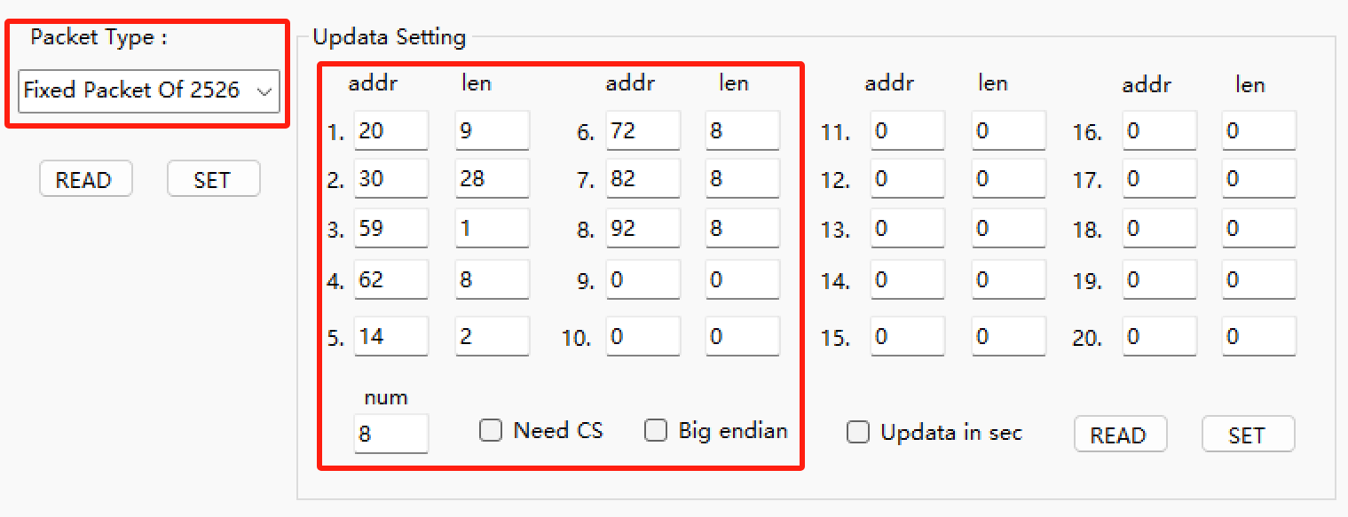

- Complete address table
If you want to freely define the content of the uploaded data, you can select the data groups from the following tables.
Description of the table :
- The first column is the start address in hexadecimal.
- The second column is the start address in decimal.
- The third column is variable name.
- The fourth column is data length (divide by 2 to get the number of register stored).
- The fifth column indicates whether the data is readable or writable.
- The sixth column describes the data type, decimal cases, and how to deal the data.

  - Secondary Data Part 1
Table 1. secondary data
Start Address  (Hexadecimal) | Start Address  （Decimal） | Variable | Length  (Bytes) | R/W | Notes
0000H | 0 | Address | 2 | R/W | 1～247
0001H | 1 | Baud rate | 2 | R/W | 1：1200bps  2：3400bps  3：4800bps  4：9600bps
0002H | 2 | Spreading factor | 2 | R/W | 6~12
0003H | 3 | Frequency channel setting | 2 | R/W | 0-45 (Communication with the same frequency host)
0004H | 4 | High byte: parity mode, low byte: stop Bit | 2 | R/W | High byte: 0-none, 1-even, 2-odd; low byte: 0- 1 stop Bit, 1- 2 stop Bit
0005H-0006H | 5-6 | Reserved
0007H | 7 | Backlight Time
0008H | 8 | Code
0009H~000CH | 9-13 | Reserved
000EH | 14 | PT
000FH | 15 | CT
0010H | 16 | Temperature of N phase | 2 | R | Int16  unit 0.1℃  If the reading value is 105, the temperature is 10.5℃
0011H~0013H | 17-19 | Time, date (second, minute, hour, day, month, year)
0014H | 20 | Voltage of A phase | 2 | R | Uint16  1 decimal places  Unit V  If U=2200，PT=1; then U=U*PT=2200*0.1*1=220.0V
0015H | 21 | Voltage of B phase | 2 | R
0016H | 22 | Voltage of C phase | 2 | R
0017H | 23 | Voltage between A-B | 2 | R
0018H | 24 | Voltage between B-C | 2 | R
0019H | 25 | Voltage between C-A | 2 | R
001AH | 26 | Current of A phase | 2 | R | Uint16  unit A  2 decimal places  If I=200，CT=10; then I=I*CT=200*0.01*10=20A
001BH | 27 | Current of B phase | 2 | R
001CH | 28 | Current of C phase | 2 | R
001DH | 29 | Vector sum of 3-phase current | 2 | R
001EH | 30 | Active power of A phase | 4 | R | Int32  unit kW  3 decimal places  If value=11720， PT=10,CT=10; then value=value*PT*CT= 11720*0.001*10*10=1172.0 kW
0020H | 32 | Active power of B phase | 4 | R
0022H | 34 | Active power of C phase | 4 | R
0024H | 36 | Total active power | 4 | R
0026H | 38 | Reactive power of A phase | 4 | R | Int32  unit kVar  3 decimal places  If value=11720， PT=10,CT=10; then value=value*PT*CT= 11720*0.001*10*10=1172.0  kVar
0028H | 40 | Reactive power of B phase | 4 | R
002AH | 42 | Reactive power of C phase | 4 | R
002CH | 44 | Total reactive power | 4 | R
002EH | 46 | Apparent power of A phase | 4 | R | Uint32  unit kVA  3 decimal places  If value=11720， PT=10,CT=10; then value=value*PT*CT= 11720*0.001*10*10=1172.0  kVA
0030H | 48 | Apparent power of B phase | 4 | R
0032H | 50 | Apparent power of C phase | 4 | R
0034H | 52 | Total apparent power | 4 | R
0036H | 54 | Power factor of A phase | 2 | R | Uint16  3 decimal places  If value=999, then value=999*0.001=0.999
0037H | 55 | Power factor of B phase | 2 | R
0038H | 56 | Power factor of C phase | 2 | R
0039H | 57 | Total power factor | 2 | R
003AH | 58 | State of DI | 2 | R | Uint16  Bit0：DI1  Bit1：DI2  Bit2：DI3  Bit3：DI4
003BH | 59 | Frequency of power | 2 | R | Uint16  2 decimal places  If value=5000,then value=5000*0.01=50.00HZ
003CH | 60 | Total energy consumption | 4 | R | Uint32  unit kWh  2 decimal places  If value=120201， PT=10,CT=10;then value=value*PT*CT= 120201*0.01*10*10=120201 kWh
003EH | 62 | Forward active energy consumption | 4 | R
0040H | 64 | Reversing active energy consumption | 4 | R
0042H | 66 | Forward reactive energy consumption | 4 | R | Uint32  unit kVarh  2 decimal places  If value=120201， PT=10,CT=10;then value=value*PT*CT= 120201*0.01*10*10=120201 kVarh
0044H | 68 | Reversing reactive energy consumption | 4 | R
0046H | 70 | Total energy consumption on A phase | 4 | R | Uint32  unit kWh  2 decimal places  If value=120201， PT=10,CT=10;then value=value*PT*CT= 120201*0.01*10*10=120201  kWh
0048H | 72 | Forward active energy consumption on A phase | 4 | R
004AH | 74 | Reversing active energy consumption on A phase | 4 | R
004CH | 76 | Forward reactive energy consumption on A phase | 4 | R | Uint32  unit kVarh  2 decimal places  If value=120201， PT=10,CT=10;then value=value*PT*CT= 120201*0.01*10*10=120201 kVarh
004EH | 78 | Reversing reactive energy consumption on A phase | 4 | R
0050H | 80 | Total energy consumption on B phase | 4 | R | Uint32  unit kWh  2 decimal places  If value=120201， PT=10,CT=10;then value=value*PT*CT= 120201*0.01*10*10=120201  kWh
0052H | 82 | Forward active energy consumption on B phase | 4 | R
0054H | 84 | Reversing active energy consumption on B phase | 4 | R
0056H | 86 | Forward reactive energy consumption on B phase | 4 | R | Uint32  unit kVarh  2 decimal places  If value=120201， PT=10,CT=10;then value=value*PT*CT= 120201*0.01*10*10=120201 kVarh
0058H | 88 | Reversing reactive energy consumption on B phase | 4 | R
005AH | 90 | Total energy consumption on C phase | 4 | R | Uint32  unit kWh  2 decimal places  If value=120201， PT=10,CT=10;then value=value*PT*CT= 120201*0.01*10*10=120201  kWh
005CH | 92 | Forward active energy consumption on C phase | 4 | R
005EH | 94 | Reversing active energy consumption on C phase | 4 | R
0060H | 96 | Forward reactive energy consumption on C phase | 4 | R | Uint32  unit kVarh  2 decimal places  If value=120201， PT=10,CT=10;then value=value*PT*CT= 120201*0.01*10*10=120201 kVarh
0062H | 98 | Reversing reactive energy consumption on C phase | 4 | R
0064H | 100 | Maximum forward active demand in current month | 4 | R | Uint32  unit KW  3 decimal places  If value=11202,PT=10,CT=10; then value=value*PT*CT= 11202*0.001*10*10=1120.2 kW
0066H~0067H | 102-103 | Occur time | 4 | R | Minute, hour, day, month
0068H | 104 | Maximum reversing active demand in current month | 4 | R | Uint32  unit kVar  3 decimal places  If value=11202,PT=10,CT=10; then value=value*PT*CT= 11202*0.001*10*10=1120.2  kVar
006AH~006BH | 106-107 | Occur time | 4 | R | Minute, hour, day, month
006CH | 108 | Maximum forward reactive demand in current month | 4 | R | Uint32  unit kVar  3 decimal places  If value=11202,PT=10,CT=10; then value=value*PT*CT= 11202*0.001*10*10=1120.2  kVar
006EH~006FH | 110-111 | Occur time | 4 | R | Minute, hour, day, month
0070H | 112 | Maximum reversing reactive demand in current month | 4 | R | Uint32  unit kVar  3 decimal places  If value=11202,PT=10,CT=10; then value=value*PT*CT= 11202*0.001*10*10=1120.2  kVar
0072H~0073H | 114-115 | Occur time | 4 | R | Minute, hour, day, month
0074H | 116 | THDUa | 2 | R | Total distortion rate of voltage and current on each phase  Uint16  2 decimal places  If value= 2425,then value=2425*0.01=25.24%
0075H | 117 | THDUb | 2 | R
0076H | 118 | THDUc | 2 | R
0077H | 119 | THDIa | 2 | R
0078H | 120 | THDIb | 2 | R
0079H | 121 | THDIc | 2 | R
007AH | 122 | THUa(Harmonic on 2nd-31st) | 2×30 | R | Harmonic voltage on 2nd-31st  Uint16  2 decimal places  If value= 2425,then value=2425*0.01=25.24%
0098H | 152 | THUa(Harmonic on 2nd-31st) | 2×30 | R
00B6H | 182 | THUb(Harmonic on 2nd-31st) | 2×30 | R
00D4H | 212 | THUc(Harmonic on 2nd-31st) | 2×30 | R | Harmonic current on 2nd-31st  Uint16  2 decimal places  If value= 2425,then value=2425*0.01=25.24%
00F2H | 242 | THIa(Harmonic on 2nd-31st) | 2×30 | R
0110H | 272 | THIb(Harmonic on 2nd-31st) | 2×30 | R
012EH | 302 | Fundamental voltage on A phase | 2 | R | Uint16  unit V  1 decimal places  If U=1010，PT=6; then U=U*PT=1010*0.1*6=606V
012FH | 303 | Fundamental voltage on B phase | 2 | R
0130H | 304 | Fundamental voltage on C phase | 2 | R
0131H | 305 | Harmonic voltage on A phase | 2 | R
0132H | 306 | Harmonic voltage on B phase | 2 | R
0133H | 307 | Harmonic voltage on C phase | 2 | R
0134H | 308 | Fundamental current on A phase | 2 | R | Uint16  unit A  2 decimal places  If I=200，CT=10; I=I*CT=200*0.01*10=20A
0135H | 309 | Fundamental current on B phase | 2 | R
0136H | 310 | Fundamental current on C phase | 2 | R
0137H | 311 | Harmonic current on A phase | 2 | R
0138H | 312 | Harmonic current on B phase | 2 | R
0139H | 313 | Harmonic current on C phase | 2 | R
013AH | 314 | Fundamental active power on A phase | 4 | R | Int32  unit kW  3 decimal places  If value=11720， PT=10,CT=10; then value=value*PT*CT= 11720*0.001*10*10=1172.0 kW
013CH | 316 | Fundamental active power on B phase | 4 | R
013EH | 318 | Fundamental active power on C phase | 4 | R
0140H | 320 | Fundamental active power | 4 | R
0142H | 322 | Fundamental reactive power on A phase | 4 | R | Int32  unit kVar  3 decimal places  If value=11720， PT=10,CT=10; then value=value*PT*CT= 11720*0.001*10*10=1172.0 kVar
0144H | 324 | Fundamental reactive power on B phase | 4 | R
0146H | 326 | Fundamental reactive power on C phase | 4 | R
0148H | 328 | Fundamental reactive power | 4 | R
014AH | 330 | Harmonic active power on A phase | 4 | R | Int32  unit kW  3 decimal places  If value=11720， PT=10,CT=10; then value=value*PT*CT= 11720*0.001*10*10=1172.0 kW
014CH | 332 | Harmonic active power on B phase | 4 | R
014EH | 334 | Harmonic active power on C phase | 4 | R
0150H | 336 | Harmonic active power | 4 | R
0152H | 338 | Harmonic reactive power on A phase | 4 | R | Int32  unit kVar  3 decimal places  If value=11720， PT=10,CT=10; then value=value*PT*CT= 11720*0.001*10*10=1172.0 kVar
0154H | 340 | Harmonic reactive power on B phase | 4 | R
0156H | 342 | Harmonic reactive power on C phase | 4 | R
0158H | 344 | Harmonic reactive power | 4 | R
015AH | 346 | Current forward active demand | 4 | R | Uint32  unit kW  3 decimal places  If value=11720， PT=10,CT=10; then value=value*PT*CT= 11720*0.001*10*10=1172.0  kW
015CH | 348 | Current reversing active demand | 4 | R
015EH | 350 | Current forward reactive demand | 4 | R | Uint32  unit kVar  3 decimal places  If value=11720， PT=10,CT=10; then value=value*PT*CT= 11720*0.001*10*10=1172.0 kVar
0160H | 352 | Current reversing reactive demand | 4 | R
0162H | 354 | Voltage imbalance | 2 | R | Uint16  unit 0.01%  If value=2201,then  value= 2201*0.01=22.01%
0163H | 355 | Current imbalance | 2 | R
0164H | 356 | Temperature on A phase | 2 | R | Int16  unit 0.1℃
0165H | 357 | Temperature on B phase | 2 | R
0166H | 358 | Temperature on C phase | 2 | R
0167H | 359 | Time zone number/Time zone date: day | 2 | R/W | Time list
0168H | 360 | Time zone date: month/Time zone number | 2 | R/W
0169H | 361 | Time zone date: day/ Time zone date: month | 2 | R/W
016AH | 362 | Time zone number/Time zone date: day | 2 | R/W
016BH | 363 | Time zone date: month/Time zone number | 2 | R/W
016CH | 364 | Time zone date: day/ Time zone date: month | 2 | R/W
016DH  …  0181H | 365-385 | 1-14 period of time Parameters setting information | 2 | R/W | 1# time list
0182H  …  0196H | 386-406 | 1-14 period of time Parameters setting information | 2 | R/W | 2# time list
0197H | 407 | Current total spike active energy | 4 | R | Uint32  unit kWh  2 decimal places  If value=120201， PT=10,CT=10;then value=*PT*CT= 120201*0.01*10*10=120201 kWh
0199H | 409 | Current total peak active energy | 4 | R
019BH | 411 | Current total flat active energy | 4 | R
019DH | 413 | Current total valley active energy | 4 | R
019FH | 415 | Current total spike forward active energy | 4 | R
01A1H | 417 | Current total peak forward active energy | 4 | R
01A3H | 419 | Current total flat forward active energy | 4 | R
01A5H | 421 | Current total valley forward active energy | 4 | R
01A7H | 423 | Current total spike reversing active energy | 4 | R
01A9H | 425 | Current total peak reversing active energy | 4 | R
01ABH | 427 | Current total flat reversing active energy | 4 | R
01ADH | 429 | Current total valley reversing active energy | 4 | R
01AFH | 431 | Current total spike forward reactive energy | 4 | R | Uint32  unit kVarh  2 decimal places  If value=120201， PT=10,CT=10;then value=*PT*CT= 120201*0.01*10*10=120201  kVarh
01B1H | 433 | Current total peak forward reactive energy | 4 | R
01B3H | 435 | Current total flat forward reactive energy | 4 | R
01B5H | 437 | Current total valley forward reactive energy | 4 | R
01B7H | 439 | Current total spike reversing reactive energy | 4 | R
01B9H | 441 | Current total peak reversing reactive energy | 4 | R
01BBH | 443 | Current total flat reversing reactive energy | 4 | R
01BDH | 445 | Current total valley reversing reactive energy | 4 | R
01BFH | 447 | wireless signal strength | 2 | R | Int16
01C0H | 448 | Freeze time | 2 | R/W | High byte:Hour，  low byte:DAY
01C1H | 449 | Aftercurrent | 2 | R | Uint16  unit mA  If I=20，CT=10; then I=I*CT=20*10=200mA
01C2H | 450 | DO1 | 2 | R/W | Uint16  Bit0 effective
01C3H | 451 | DO2 | 2 | R/W | Uint16  Bit0 effective
01C4H | 452 | Demand cycle | 2 | R/W | 1：15min  2：30min  3：45min  4：60min
01C5H-01CFH | 453-463 | reserved
01D0H-01EBH | 464-491 | Related data of alarm 1, see section 6.3.1 for details
01ECH | 492 | A phase voltage Angle | 2 | R | Uint16  2 decimal places  If value= 9011, then value=9011*0.01=90.11°
01EDH | 493 | B phase voltage Angle | 2 | R
01EEH | 494 | C phase voltage Angle | 2 | R
01EFH | 495 | reserved
01F0H | 496 | Protocol selection bit | 2 | R/W | 0：安全用电  1：电力运维
01F2H | 498 | Real-time perceived demand | 4 | R | Uint32  unit kVA  3 decimal places  If value=11720， PT=10,CT=10; then value=value*PT*CT= 11720*0.001*10*10=1172.0  kVA
01F4H | 500 | Combined reactive electric energy | 4 | R | Uint32  unit kVarh  2 decimal places  If value=120201， PT=10.0,CT=10; then value=value*PT*CT= 120201*0.01*10*10=120201  kVarh
01F6H | 502 | Current first quadrant of reactive energy | 4 | R
01F8H | 504 | Current second quadrant reactive energy | 4 | R
01FAH | 506 | Current third quadrant of reactive energy | 4 | R
01FCH | 508 | Current fourth quadrant reactive energy | 4 | R
01FEH | 510 | A phase current Angle | 2 | R | Uint16  2 decimal places  If value=9011,then value=9011*0.01=90.11°
01FFH | 511 | B phase current Angle | 2 | R
0200H | 512 | C phase current Angle | 2 | R
0201H-0215H | 513-533 | 1-14 period of time Parameters setting information | 2 | R/W | 3# time list
0216H-0249H | 534-585 | Related data of alarm 2 and alarm 3, see section 6.3.2 for details
024AH-0267H | 586-615 | reserved
0268H-0169H | 616-617 | Alarm status of alarm 2 and alarm 3, see section 6.3.2 for details

  - Secondary Value Part 2
Table 2. Secondary Value

Start Address  （Hexadecimal） | Start Address  （Decimal） | Variable | Length  (Bytes) | R/W | Notes
8800 | 34816 | Total active energy | 4 | R | Uint 32  unit kWh
8802 | 34818 | Forward active energy consumption | 4 | R
8804 | 34820 | Reversing active energy consumption | 4 | R
8806 | 34822 | reserved | 4 | R | Uint 32  unit kVar
8808 | 34824 | Forward reactive energy consumption | 4 | R
880A | 34826 | Reversing reactive energy consumption | 4 | R
880C | 34828 | reserved | 4 | R | Uint 32  unit kVAh
880E | 34830 | Current total spike active energy | 4 | R | Uint 32  unit kWh
8810 | 34832 | Current total peak active energy | 4 | R
8812 | 34834 | Current total flat active energy | 4 | R
8814 | 34836 | Current total valley active energy | 4 | R
8816 | 34838 | Current total spike forward active energy | 4 | R
8818 | 34840 | Current total peak forward active energy | 4 | R
881A | 34842 | Current total flat forward active energy | 4 | R
881C | 34844 | Current total valley forward active energy | 4 | R
881E | 34846 | Current total spike reversing active energy | 4 | R
8820 | 34848 | Current total peak reversing active energy | 4 | R
8822 | 34850 | Current total flat reversing active energy | 4 | R
8824 | 34852 | Current total valley reversing active energy | 4 | R
8826 | 34854 | Current total spike forward reactive energy | 4 | R | Uint 32  unit kVar
8828 | 34856 | Current total peak forward reactive energy | 4 | R
882A | 34858 | Current total flat forward reactive energy | 4 | R
882C | 34860 | Current total valley forward reactive energy | 4 | R
882E | 34862 | Current total spike reversing reactive energy | 4 | R
8830 | 34864 | Current total peak reversing reactive energy | 4 | R
8832 | 34866 | Current total flat reversing reactive energy | 4 | R
8834 | 34868 | Current total valley reversing reactive energy | 4 | R
8836 | 34870 | Total active energy of A phase | 4 | R | Uint 32  unit kWh
8838 | 34872 | Forward active energy consumption of A phase | 4 | R
883A | 34874 | Reversing active energy consumption of A phase | 4 | R
883C | 34876 | reserved | 4 | R | Uint 32  unit kVar
883E | 34878 | Forward reactive energy consumption of A phase | 4 | R | Uint 32  unit kVar
8840 | 34880 | Reversing reactive energy consumption of A phase | 4 | R
8842 | 34882 | reserved | 4 | R | Uint 32  unit kWh
8844 | 34884 | reserved | 4 | R
8846 | 34886 | reserved | 4 | R
8848 | 34888 | reserved | 4 | R
884A | 34890 | Total active energy of B phase | 4 | R | Uint 32  unit kWh
884C | 34892 | Forward active energy consumption of B phase | 4 | R
884E | 34894 | Reversing active energy consumption of B phase | 4 | R
8850 | 34896 | reserved | 4 | R | Uint 32  unit kVar
8852 | 34898 | Forward reactive energy consumption of B phase | 4 | R | Uint 32  unit kVar
8854 | 34900 | Reversing reactive energy consumption of B phase | 4 | R
8856 | 34902 | reserved | 4 | R | Uint 32  unit kVar
8858 | 34904 | reserved | 4 | R
885A | 34906 | reserved | 4 | R
885C | 34908 | reserved | 4 | R
885E | 34910 | Total active energy of C phase | 4 | R | Uint 32  unit kWh
8860 | 34912 | Forward active energy consumption of C phase | 4 | R
8862 | 34914 | Reversing active energy consumption of C phase | 4 | R
8864 | 34916 | reserved | 4 | R | Uint 32  unit kVar
8866 | 34918 | Forward reactive energy consumption of C phase | 4 | R | Uint 32  unit kVar
8868 | 34920 | Reversing reactive energy consumption of C phase | 4 | R
886A | 34922 | reserved | 4 | R | Uint 32  unit kVar
886C | 34924 | reserved | 4 | R
886E | 34926 | reserved | 4 | R
8870 | 34928 | reserved | 4 | R
8872 | 34930 | Quadrant 1 Total Reactive Energy | 4 | R | Uint 32  unit kVar
8874 | 34932 | Quadrant 2 Total Reactive Energy | 4 | R
8876 | 34934 | Quadrant 3 Total Reactive Energy | 4 | R
8878 | 34936 | Quadrant 4 Total Reactive Energy | 4 | R
887A | 34938 | reserved | 4 | R
887C | 34940 | reserved | 4 | R

  - Primary Value (Real Value) Part 1
Table3.primary value

Start Address  （Hexadecimal） | Start Address  （Decimal） | Variable | Length  (Bytes) | R/W | Notes
8000 | 32768 | Voltage of Aphase | 4 | R | float32  unit V
8002 | 32770 | Voltage of B phase | 4 | R
8004 | 32772 | Voltage of C phase | 4 | R
8006 | 32774 | Voltage between A-B | 4 | R
8008 | 32776 | Voltage between B-C | 4 | R
800A | 32778 | Voltage between C-A | 4 | R
800C | 32780 | Current of Aphase | 4 | R | float32  unit A
800E | 32782 | Current of B phase | 4 | R
8010 | 32784 | Current of C phase | 4 | R
8012 | 32786 | Vector sum of  3-phase current | 4 | R
8014 | 32788 | Active power of A phase | 4 | R | float32  unit kW
8016 | 32790 | Active power of B phase | 4 | R
8018 | 32792 | Active power of C phase | 4 | R
801A | 32794 | Total active power | 4 | R
801C | 32796 | Reactive power of A phase | 4 | R | float32  unit kVar
801E | 32798 | Reactive power of B phase | 4 | R
8020 | 32800 | Reactive power of C phase | 4 | R
8022 | 32802 | Total reactive power | 4 | R
8024 | 32804 | Apparent power of A phase | 4 | R | float32  unit kVA
8026 | 32806 | Apparent power of B phase | 4 | R
8028 | 32808 | Apparent power of C phase | 4 | R
802A | 32810 | Total apparent power | 4 | R
802C | 32812 | Power factor of A phase | 4 | R | float32
802E | 32814 | Power factor of B phase | 4 | R
8030 | 32816 | Power factor of C phase | 4 | R
8032 | 32818 | Total power factor | 4 | R
8034 | 32820 | Frequency of power | 4 | R | float32  unit HZ
8036 | 32822 | The average phase voltage | 4 | R | float32  unit v
8038 | 32824 | Line voltage average | 4 | R
803A | 32826 | Current average | 4 | R | float32  unit A
803C | 32828 | Voltage imbalance | 4 | R | float32  unit 0.1%
803E | 32830 | Current imbalance | 4 | R
8040 | 32832 | residual voltage | 4 | R | float32  unit v
8042 | 32834 | residual current | 4 | R | float32  unit A
8044 | 32836 | A Power Angle | 4 | R | float32  unit 0.1°
8046 | 32838 | B Power Angle | 4 | R
8048 | 32840 | C Power Angle | 4 | R
804A | 32842 | Phase A voltage angle | 4 | R
804C | 32844 | Phase B voltage angle | 4 | R

  - Primary Value (Real Value) Part 2
Table4.primary value

Start Address  （Hexadecimal） | Start Address  （Decimal） | Variable | Length  (Bytes) | R/W | Notes
887E | 34942 | Total active energy | 4 | R | Float 32  unit kWh
8880 | 34944 | Forward active energy consumption | 4 | R
8882 | 34946 | Reversing active energy consumption | 4 | R
8884 | 34948 | reserved | 4 | R | Float 32  unit kVar
8886 | 34950 | Forward reactive energy consumption | 4 | R
8888 | 34952 | Reversing reactive energy consumption | 4 | R
888A | 34954 | reserved | 4 | R | Float 32  unit kVAh
888C | 34956 | Current total spike active energy | 4 | R | Float 32  unit kWh
888E | 34958 | Current total peak active energy | 4 | R
8890 | 34960 | Current total flat active energy | 4 | R
8892 | 34962 | Current total valley active energy | 4 | R
8894 | 34964 | Current total spike forward active energy | 4 | R
8896 | 34966 | Current total peak forward active energy | 4 | R
8898 | 34968 | Current total flat forward active energy | 4 | R
889A | 34970 | Current total valley forward active energy | 4 | R
889C | 34972 | Current total spike reversing active energy | 4 | R
889E | 34974 | Current total peak reversing active energy | 4 | R
88A0 | 34976 | Current total flat reversing active energy | 4 | R
88A2 | 34978 | Current total valley reversing active energy | 4 | R
88A4 | 34980 | Current total spike forward reactive energy | 4 | R | Float 32  unit kVar
88A6 | 34982 | Current total peak forward reactive energy | 4 | R
88A8 | 34984 | Current total flat forward reactive energy | 4 | R
88AA | 34986 | Current total valley forward reactive energy | 4 | R
88AC | 34988 | Current total spike reversing reactive energy | 4 | R
88AE | 34990 | Current total peak reversing reactive energy | 4 | R
88B0 | 34992 | Current total flat reversing reactive energy | 4 | R
88B2 | 34994 | Current total valley reversing reactive energy | 4 | R
88B4 | 34996 | Total active energy of A phase | 4 | R | Float 32  unit kWh
88B6 | 34998 | Forward active energy consumption of A phase | 4 | R
88B8 | 35000 | Reversing active energy consumption of A phase | 4 | R
88BA | 35002 | reserved | 4 | R | Float 32  unit kVar
88BC | 35004 | Forward reactive energy consumption of A phase | 4 | R | Float 32  unit kVar
88BE | 35006 | Reversing reactive energy consumption of A phase | 4 | R
88C0 | 35008 | reserved | 4 | R | Float 32  unit kWh
88C2 | 35010 | reserved | 4 | R
88C4 | 35012 | reserved | 4 | R
88C6 | 35014 | reserved | 4 | R
88C8 | 35016 | Total active energy of B phase | 4 | R | Float 32  unit kWh
88CA | 35018 | Forward active energy consumption of B phase | 4 | R
88CC | 35020 | Reversing active energy consumption of B phase | 4 | R
88CE | 35022 | reserved | 4 | R | Float 32  unit kVar
88D0 | 35024 | Forward reactive energy consumption of B phase | 4 | R | Float 32  unit kVar
88D2 | 35026 | Reversing reactive energy consumption of B phase | 4 | R
88D4 | 35028 | reserved | 4 | R | Float 32  unit kWh
88D6 | 35030 | reserved | 4 | R
88D8 | 35032 | reserved | 4 | R
88DA | 35034 | reserved | 4 | R
88DC | 35036 | Total active energy of C phase | 4 | R | float 32  unit kWh
88DE | 35038 | Forward active energy consumption of C phase | 4 | R
88E0 | 35040 | Reversing active energy consumption of C phase | 4 | R
88E2 | 35042 | reserved | 4 | R | Float 32  unit kVar
88E4 | 35044 | Forward reactive energy consumption of C phase | 4 | R | float 32  unit kVar
88E6 | 35046 | Reversing reactive energy consumption of C phase | 4 | R
88E8 | 35048 | reserved | 4 | R | float 32  unit kVar
88EA | 35050 | reserved | 4 | R
88EC | 35052 | reserved | 4 | R
88EE | 35054 | reserved | 4 | R
88F0 | 35056 | Quadrant 1 Total Reactive Energy | 4 | R | float 32  unit kVar
88F2 | 35058 | Quadrant 2 Total Reactive Energy | 4 | R
88F4 | 35060 | Quadrant 3 Total Reactive Energy | 4 | R
88F6 | 35062 | Quadrant 4 Total Reactive Energy | 4 | R
88F8 | 35064 | reserved | 4 | R
88FA | 35066 | reserved | 4 | R

